### Delta Table Schema Evolution

we learned that Delta table comes with some type of schema validations in place. It's not very strict in all cases yet, but it comes with some kind of schema validation in place. But how to overcome that? Schema validation limitations. What if we want to add new records with different column names or with additional new columns? What if we want to allow them so how we work with that. That's the idea behind schema evolution. Can we evolve the schema of an existing delta table? Can we do that? That's what we are going to learn in this lecture. So let's start with the some examples I have set up a Notebook for that as well. And I'll come to schema evolution notebook. Connect my cluster. before we start doing anything, let's do some cleanup.

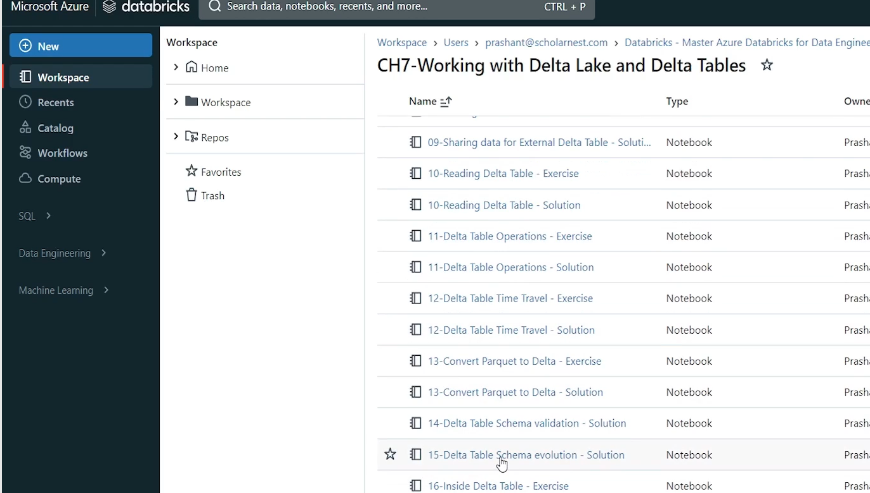

So we have a clean environment and then I do some setup. So basically what we are trying to do, we are trying to create a people table. It's a delta table. And we are creating that delta table. And we are also inserting some records, from a file into the delta table. So my delta table comes with some pre-existing records. I already have a delta table. And the current delta table looks like this.

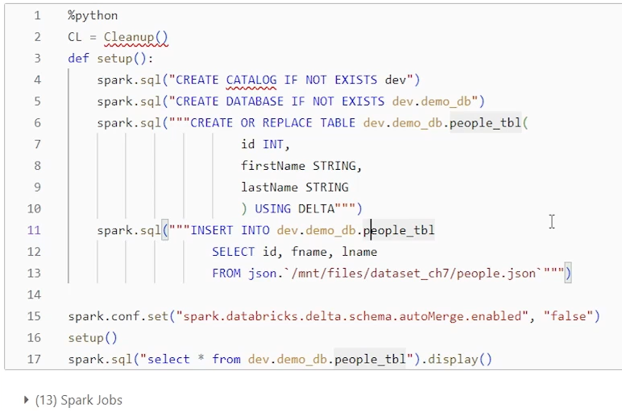

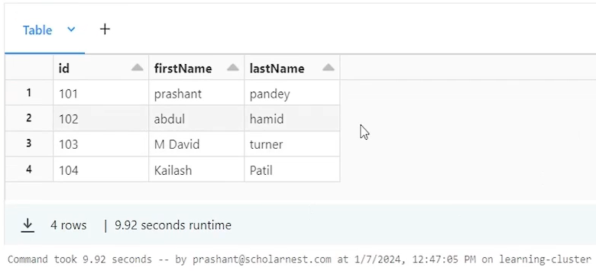

We have four records. We have three columns, super simple delta table ID, first name, last name. Now we want to ingest new data into this table. And data comes with schema changes right. Maybe some new columns. Are there some new fields are there. And we know that Delta table comes with some predefined schema validations. So it might not allow me to insert data into this table if we get some new fields. Right. But how do we overcome that problem? If I have a requirement to insert new fields into this table and evolve the schema of this table with additional fields, how can we do that? So I have included the schema validation summary here that we learned in the earlier lecture, so you can go through it.

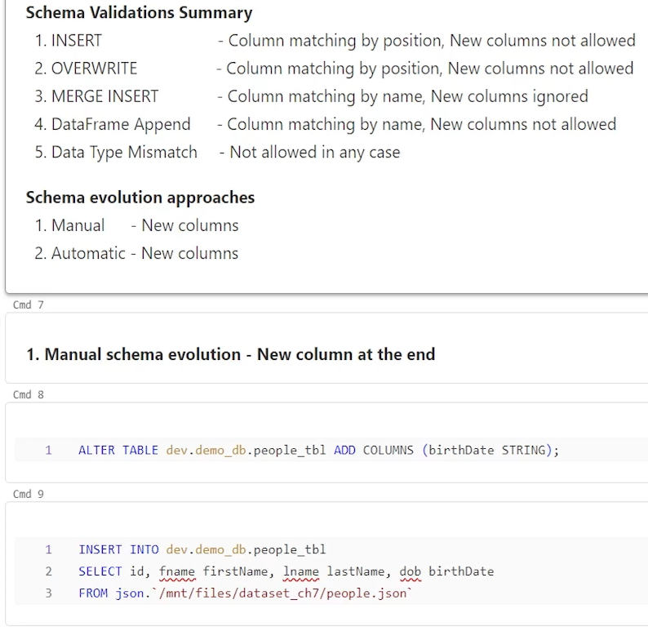

I have already covered that in the earlier lecture also. But in summary, what we want to understand, there are two approaches for schema evolution. One is manual approach, another one is automatic approach. In the manual approach, we can, evolve the schema of our existing delta table manually. And then. Insert new records or new data set into that table. In Automatic Schema Evolution approach, we configure our project in a way that when new data, new columns are coming in the input, it automatically evolves. The schema, automatically adds new columns into the table, evolves the schema, and then accepts the new data. So let's try to understand the mechanics of both the approaches. So first scenario here is I'm trying to insert into people table from this source. And. I have id. F name which is renamed as first name. L name which is renamed as last name and date of birth. But date of birth is a new column. It doesn't exist in the table. So if I try to insert it. If I try to run this insert statement, it should throw me an error, right? Because we know in the insert into additional columns are not allowed. It will throw a schema mismatch, error. But I have a requirement I want to accept this new column for new records. How can I do it? I have to evolve my, tables schema. How do how can I evolve my table schema manually?

One approach is manually schema evolution. Simple. Go alter the table, add new column and then you will be allowed to insert your data. So I'll go alter my table. I'm simply using alter table statement, add columns and I want to add one new column birth date data type is string. So table is modified. And now. I can run my data ingestion pipeline again. it throwed an error earlier, so if I run it again, it should allow inserting new records. Right.

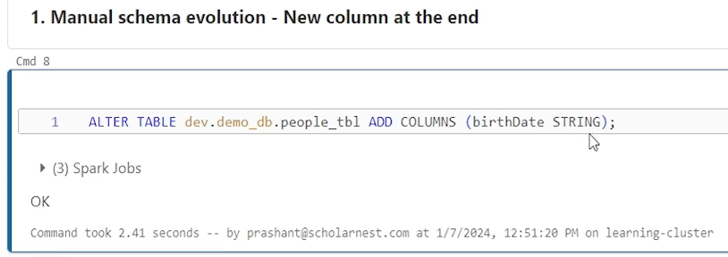

So I've inserted some new records. Fourth column is also inserted because I altered the table. So that's how manual schema evolution works. what if the new column is in the middle? We saw there is a new column coming up at the end. What if the new column is coming in the middle? So let's say my select statement is like ID, first name, last name, date of birth column is already there in my target table, but now there is a phone number column coming in between. So will that work? I can try running it. It will not work.

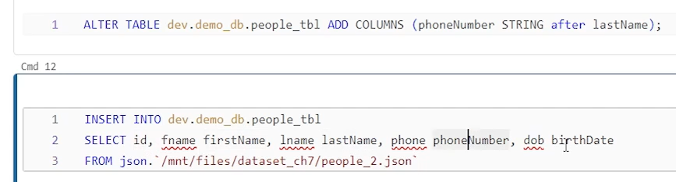

Because we have. One, two, three, four, five columns now in my ingestion pipeline. But the delta table that I have behind the scene here, my target table has got only four columns. So there is one extra column. Definitely it will throw an, schema validation error. So how can I add one extra column in the middle? That's easy. In spark you have an alter table statement to add columns and give the column name and tell the position maybe after last name. Right. So I want to add an extra column in between before date of birth or after last name so I can alter my table like this. And. I can evolve my schema even to add extra columns in the middle.

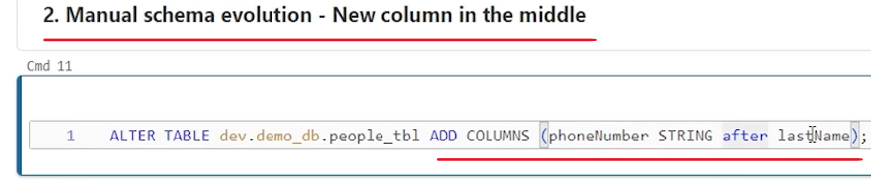

And, once that is done, I can run an ingestion pipeline which will allow me to insert new records.

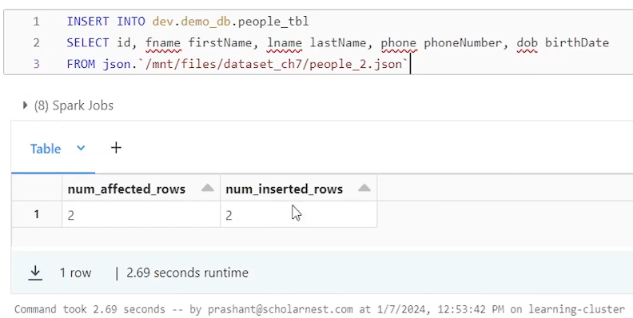

And if you look at your table after ingestion, it should show you all the five columns the phone number column is inserted, added in between before the date of birth or after the last name.

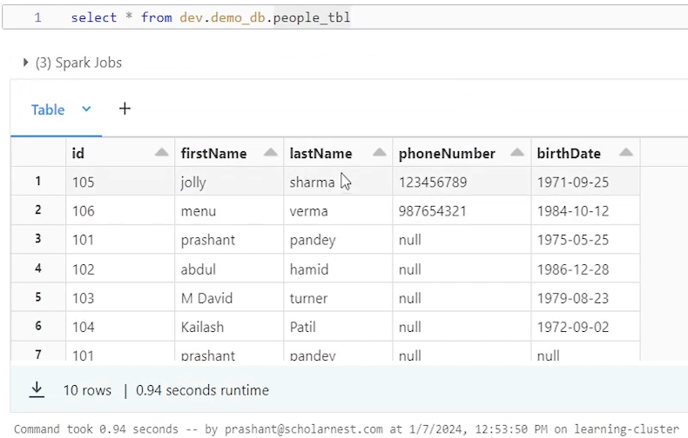

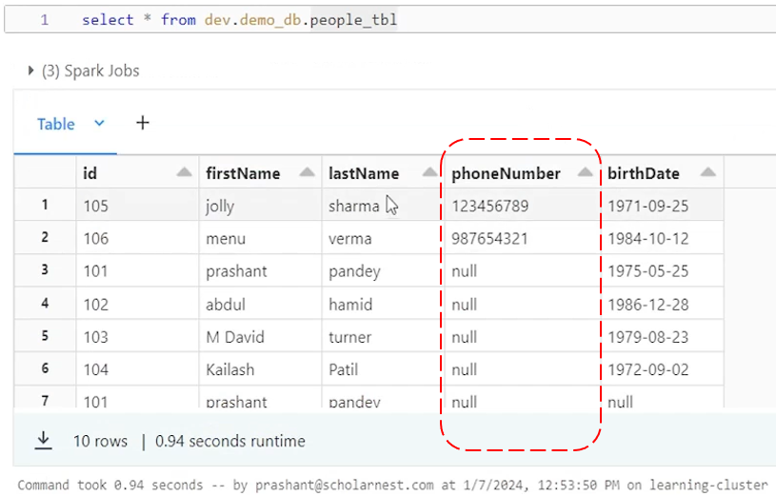

I inserted two records and phone number is inserted correctly. Existing records will remain. These fields will. The new field will remain null because it wasn't there when I ingested these existing data earlier. So that's how schema evolution works. manually. So if you are having new columns coming in, you can manually evolve your schema using Alter Table and then rerun your pipelines. Your pipeline initially will fail, obviously because of schema validation error. But then you can evolve your schema using manual schema evolution using alter table statements and rerun your pipelines to start ingesting new columns. That's how, manual schema evolution works in spark projects. Manual Schema evolution is often preferred. reason is straightforward, we want to be in control, right? If my source system is sending some new columns, some extra data, I want to be notified with that. If I am notified, I'll go evolve my schema, accept the extra data, extra columns, and take a decision on what I want to do with those extra columns. Do we have some business logic related to that? What do we want to do in the processing for those extra columns? Without knowing that, I don't want to silently accept those additional data and do nothing with those fields right. So that's why it's manual schema evolution is often preferred for most of the projects or in many scenarios. Many projects would want to prefer that approach, so that at least if something is, new is coming, my existing pipeline will break and I'll be notified that it is breaking with schema validation error. Ideally, my source system should tell me in advance that I'm pushing some new fields, but even if they don't tell that in advance, I'll be notified by my pipeline failing with an schema validation error. So that's how manual schema evolution works.

But in some projects, some scenarios, some requirements, we want to keep it going. We want to configure it in a way that let new data come in, new fields come in, let my, pipeline automatically evolve the schema and ingest those new fields, new records. And that's all, at least for my raw data ingestion layer. For my bronze layer. let's ingest the new data and then we will, think about it later. What to do with that data? I don't want my data pipeline to be breaking because some new column is added. So let's ingest it automatically and then we will figure out what to do with that new field. So that is also an approach. And for that we can configure automatic schema evolution. So let's prepare for that I'll do cleanup and setup once again. To do some demo for the automatic schema evolution.

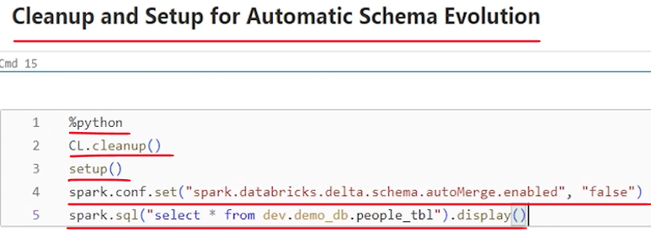

We are at stage zero where I have a table. Table name is people table. I have three columns ID, first name and last name. Four records are already there.

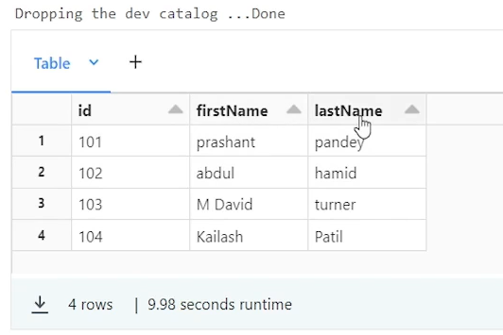

Let's assume I'm ingesting new data which comes with an extra field date of birth. It's an extra field. In a typical case, if I run this pipeline, it should fail with the schema mismatch detected.

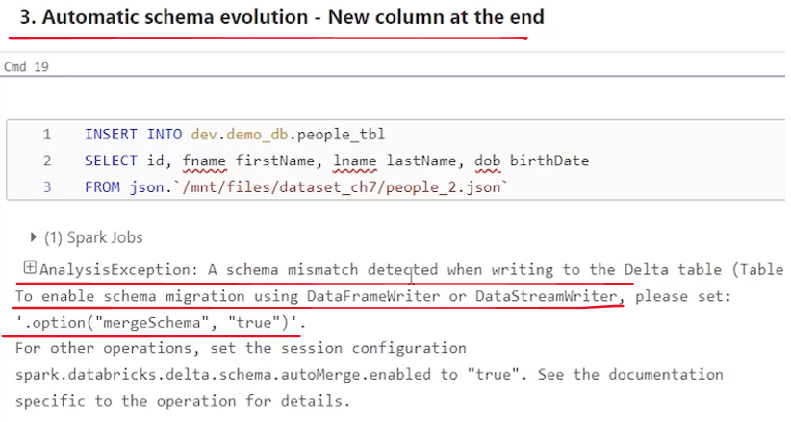

But I don't want this pipeline to fail. I want to configure automatic schema evolution so that my table, my existing data table, automatically adds a new column for date of birth and accepts it. Right. So you can configure automatic schema evolution at your session level like this. just in Databricks, you just set this spark dot Databricks dot delta dot schema, auto merge enabled equal to true. So let me set that configuration. Once this configuration is true your is automatic schema evolution is configured for your entire session.

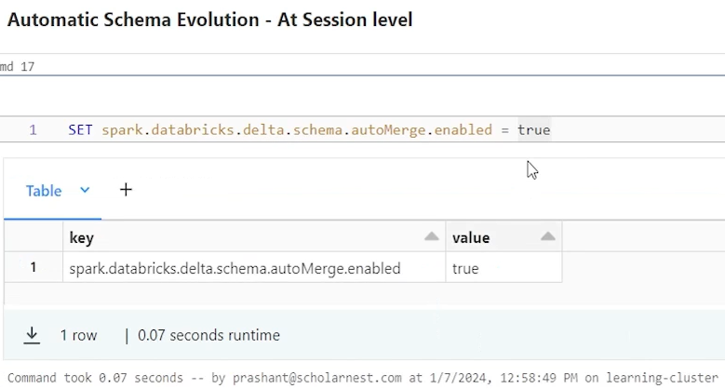

So anything and everything that you do in this session will be going for an automatic schema evolution. So if I run this, pipeline in this session, what will happen this pipeline or this ingestion ingestion code will work.

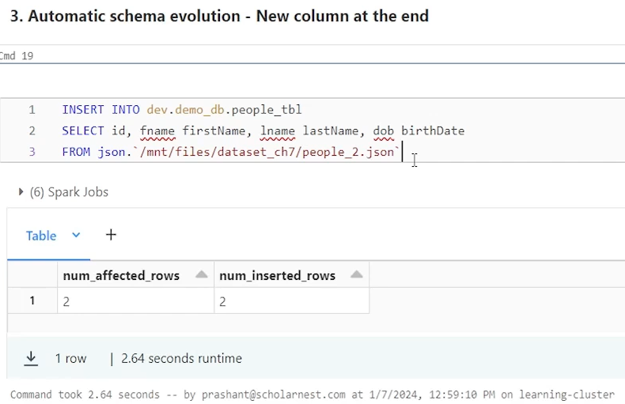

And if you want to look at your table, after this, it should have automatically added a new column. Let's run it and we can see the birth date column is automatically added.

|  |  |
| --- | --- |
| So what actually happened when I do the automatic schema evolution configuration?  This insert statement will definitely identify that this is there is a new, column coming in, but instead of failing, it will allow that new column and behind the scene automatically my table alter table statement somehow gets executed. this table is, this column is added in the table and we ingest new table. So that's how automatic schema evolution works. |  |

The second scenario is, what if we are adding a new column or we are receiving a new column in the middle? We learned in the manual schema evolution, we can run an alter table statement to add a column in the middle. But how that works in the automatic schema evolution. What happens if automatic schema evolution is enabled? And we got a new column in the middle. So here is the scenario. ID first name, last name. We got a new column in the middle phone number, date of birth we already added here. So if schema is evolved so date of birth column is already there. But I got a new field in the middle. My automatic schema evolution is enabled by default. Right. I have done that here. So will it work? Let's try that. It throws an error. I found duplicate columns in data to save birth date

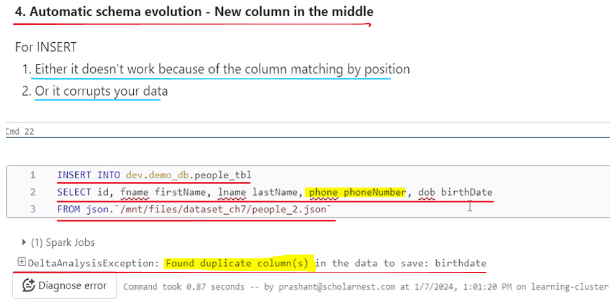

This error is because we are using an insert into statement and we learned that insert into statement behind the scene works by column position, right? Even if you use manual schema evolution or you use automatic schema evolution, the nature of the insert into statement is to match the column by position.

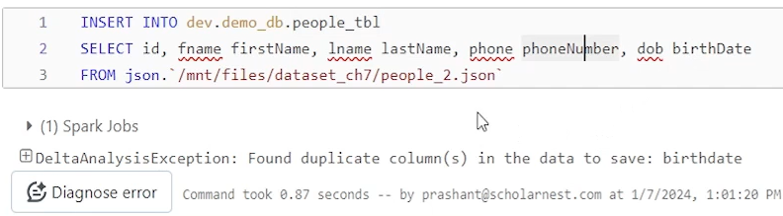

So what it is trying first ID that's the first name. first column, first name. That value goes into the second column. In this table, last name goes into the third column of this table. And phone number goes into the fourth column of this table. And fourth column in this table is birth date. So up to there things are fine. Phone number will try to go into the birth date. and this birth date will be detected as a new column. And that's why the error is saying that found duplicate columns in the data to save birth date. So due to column position problem or due to column position insert into will, either it will not work because of the column matching by position or if at all, it works somehow because the number of columns in the table and your insert statement are same, it will corrupt your data. So even if you are using automatic schema evolution, we recommend that avoid using insert into statements. for loading data into a target table. We should always prefer data frame append API's that comes with a solid schema validation and schema evolution also works well. In that scenario, we will see that.

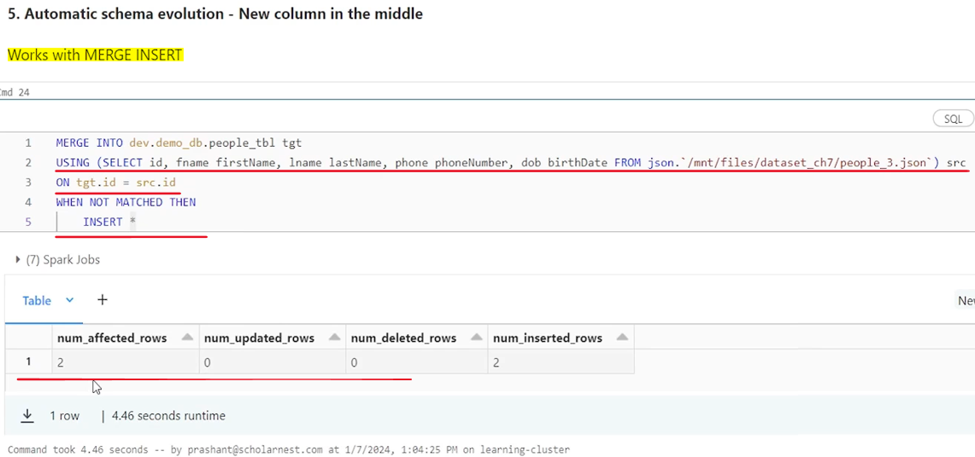

What about the merge? If the same scenario I was, trying with the merge statement where a new column is coming in the middle, will it work? So let's try that ID first column, first name, second column, last name, third column phone number is a new column coming into that. source and birth date is already there in my, table. We have already evolved the table to have the birth date column. So there is an extra column, but it is in the middle. Will that work? Let's with the merge into. Let's try that. We know that merge into works by column name right. It doesn't matches by position. So if we run that. Merge statement works. And what is the state of the table at the end? If you look at this new column, phone number is added, but at the last, not in the middle. But it doesn't matter as long as we allowed new column coming in the middle to be added. My schema to be automatically evolved. It is fine, right? That's what we want to do. Column is added in the middle or at the end is not that relevant. So merge statement works pretty well. with the automatic schema evolution. Even if column is coming, new columns are coming at the end or it comes in between somewhere. And then, we learned how automatic schema works at the session level. Right. You can set this, configuration and automatic schema evolution is enabled for the entire session.

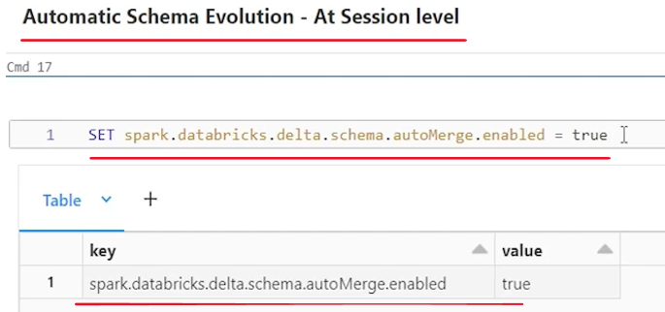

So in that session, if you are inserting data into ten tables, automatic schema evolution is enabled for all ten tables. That might not be the case that you want right? You might not want that automatic schema evolution should be enabled for all table. Maybe you want to be a little selective. So how do we enable automatic schema evolution at the table level. So let's do cleanup and setup once again to understand how things work at the table level. The recommended approach is to use data frame APIs. And that is most preferred approach for various reasons.

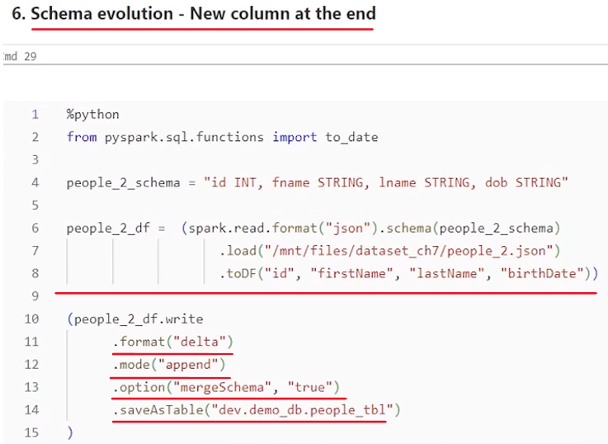

Reason one you are using Python code so you can parameterize a lot of things. You can write functions, reusable functions, call them from various places, reuse it. And you have a strict schema validation in place on your delta tables while using data frame write operations, using append mode. And you can also enable automatic schema evolution at the table level. So with each write operation you can enable or decide whether you want automatic schema evolution for this write statement or not. So that's the idea.

|  |  |
| --- | --- |
| So let's try one scenario a new column at the end. So let's say I, have this table there are three columns, four records already there.  And I am reading new data set, from people_2.json file, and the schema in the file is like this id fname lname and DOB. Right. That's the schema inside the file. So I have defined that schema and using that schema while reading the data frame. So I read it correctly up to here.  It's all about reading data from the source. But my goal is to insert this new record. Whatever I am reading from this, table into my target table, which is people table. |  |

It's a delta table. I want to insert my, data here. And I know a delta table comes with three fields. Field name is ID first name, last name. So as a best practice, I should always rename my columns in the source, to match it with the. Column names in my target table, so I'm using two DF to rename my columns. First column I want it to become ID. Second column I want to become first name. It was F name in the source, and third column I want to become it as last name. It was lname in the source and last column, which is a new column. I want to become this as, birth date. It is DOB in the target.

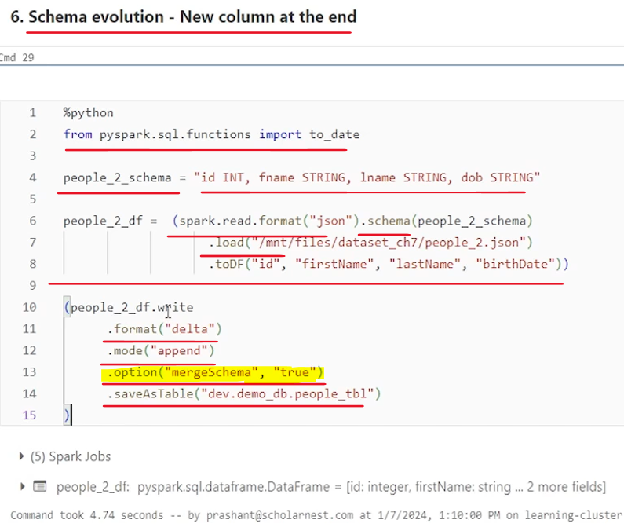

So what I want I want to insert this, data frame into my existing table. I know there are three fields. I want, to automatically evolve the schema if I'm getting fourth field also. And the fourth field name should be birth date, so I'm prepared for that. And finally, what you can do you can use this data frame right format delta mode append and save as table into an existing table. And it should insert a record into that table. But since I want automatic schema evolution I can use this option. So option merge schema equal to true. And it will allow you to automatically evolve the schema if you are receiving some new tables. So let's run this. And we know that this is working at this table level, not even the table level at this insert level right at this. Right. So I have full flexibility if I want to implement automatic schema evolution for this write statement, I can use this option if I want to go with the manual schema evolution approach I can avoid using this option. And it worked. So if you go and check your table, you should have got the birth date column added and data should be available, right?

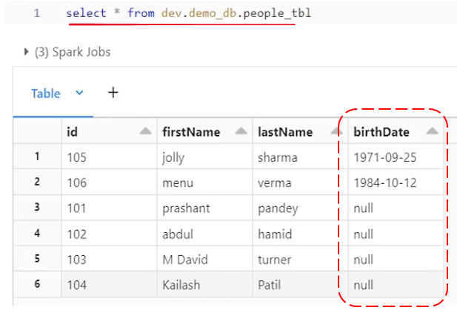

We have the new column and new records has got the birth date. Old records are still null for the birth date column. And that's what happens if you receive new data with new column and accommodate that new data into same existing table. What if column is coming in the middle.

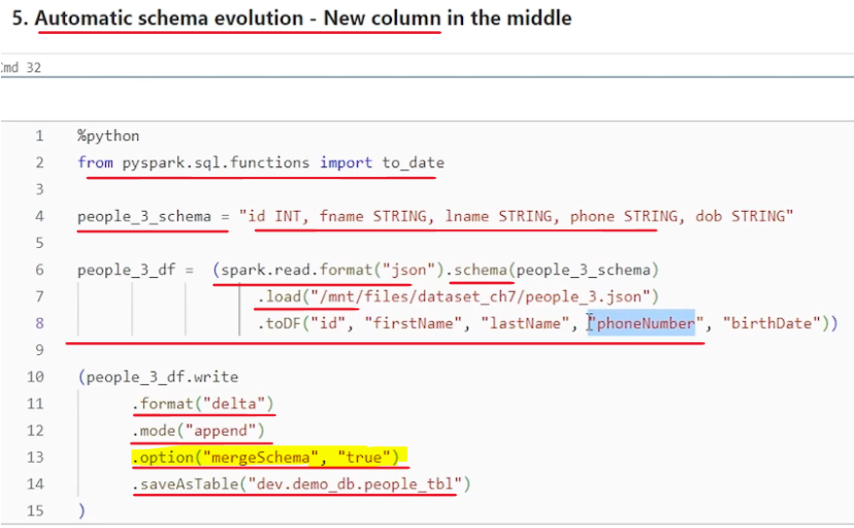

So same same scenario, similar code setup I have done here where we know that phone number is coming in the middle. so I am preparing this data frame reading data from people three dot Json I have 12345 fields in the table. We already have four fields. But there is a phone number column, new column coming in between in my source.

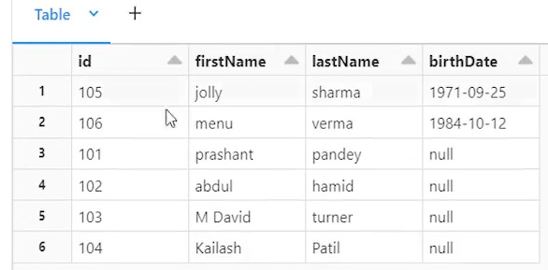

Will that work with an automatic schema evolution? Let's see. I have enabled merge schema. True. And let's see if this code allows me to automatically evolve this schema. So it worked without error.

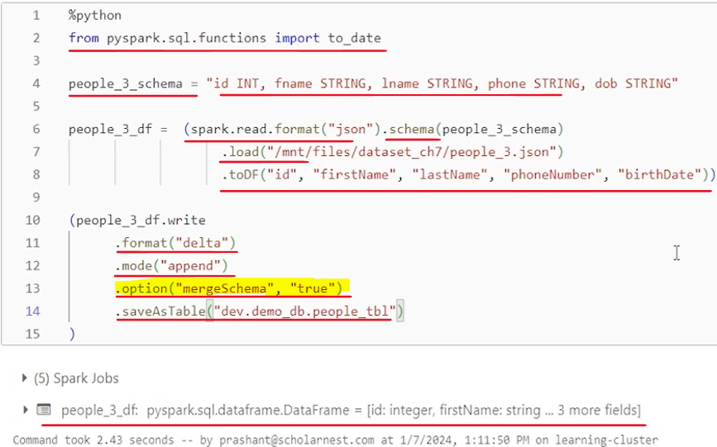

If we look at the table, new column phone number is added, not in the middle but at the end. But it, worked pretty well, right? Birth date is inserted into birth date, and phone number is inserted into, phone number, and data is going in, pretty much where I wanted to, wanted it to go.

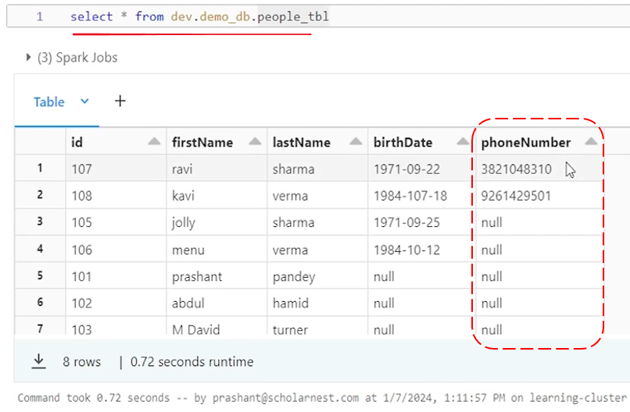

So that's what about the schema validation and schema evolution? It's a complex topic. Things are not, standard everywhere, but we have the options. We have the options where your schema is validated and you can get an error, or you can get it notified that something new is coming. You want to accommodate it now.

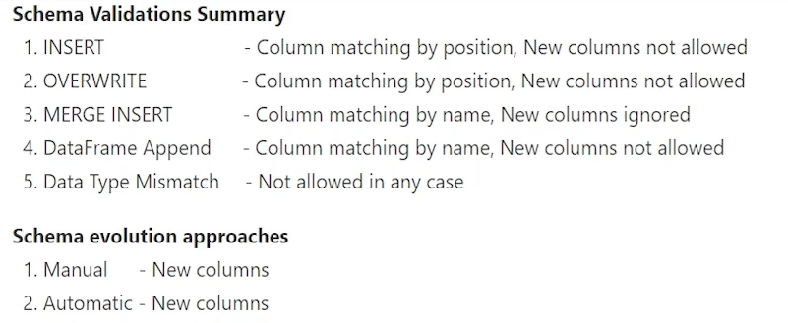

And then for accommodating that new fields you have two options. Go for manual schema evolution. Or you can go for an automatic schema evolution. And in that all which is allowed is to ingest new fields, new columns into your, target table. If data type is evolving, for example, a string field is changing into timestamp field now, right. That kind of evolution is rare, right? When you designed when you started ingesting one field, you come up with the data type at that time, evolving data type or changing data type for an existing column is a rare scenario. It doesn't often happens in real life and that kind of evolution is not allowed in spark. You cannot do it using manual evolution. You cannot do it using automatic evolution. You cannot alter a table either manually or automatically changing data type of a column. There is no solution for that.

If at all, you have a requirement just in case. It rarely happens, but if at all you have a requirement, you have to build a custom solution. You have to come up with the logic. There are various approaches, maybe you create a new table with a new data type column data type. Move data from this table to a the new table from the old table to new table. Migrate your data right with all the existing data field columns translated into the new data type. Or maybe you add a new column in the same table, a new column with the new data type. For example, let's say birth date was a string earlier. Now you want to evolve it to, date field. So maybe you can add one more birth date one column or birth date, underscore date column in the same table and start ingesting new records with date type data type for birth into that column. Existing records that new column value will be null, and later you can work out a solution where you migrate the old birth date column to a new birth date column with a custom code. And once that migration is successfully completed, you can drop or delete the old birth date column. So for data type evolution, we will always have to work with some custom solution. Take a custom approach. But if you are receiving new columns that's pretty much straight. You can evolve your tables either manually or automatically and start accepting, new data type. But schema evolution is a complex area. It will need to be very careful, very cautious, and design the solution with extra care. That's all for, schema validation and schema evolution in delta tables.

### A Look inside the Delta Table

**What are delta tables?**

What is inside the delta table? How delta table works behind the scene. That's what we want to understand in this lecture. So let's start. Let me go to my workspace and I have set up a demo notebook for this also. So let's go to my notebook. Attach a cluster. And. Do the cleanup. And also. Do some setup. So basically what I'm doing as part of the setup, I created a dev catalog and I created a demo DB database.

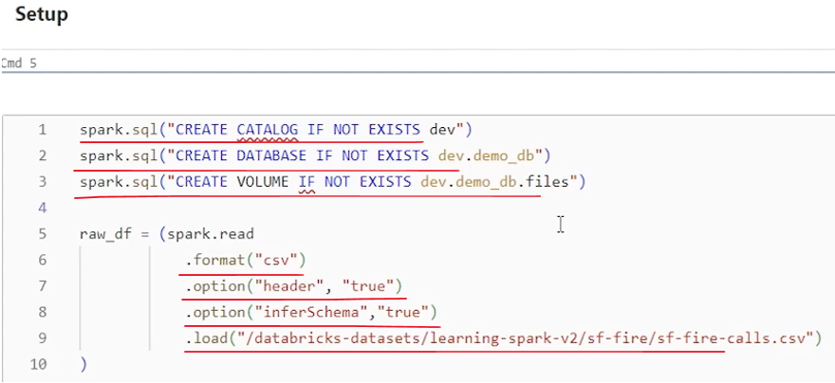

And inside this database I have created a volume. The volume name is files. Uh, I created a volume so that I can save, uh, data set in delta format. We know that delta table and delta format data set are the same, with one minor exception. When you create a delta table. Delta table consists of delta. Format data set plus metadata in your catalog. Right. So with that metadata you can use spark SQL queries using the Delta table name like select star from your delta table name. Uh, but you can also have a delta format data set without a metadata. It's still delta format data set and it can exist in a directory. And that's what I'm trying to set up here. Only delta format data set. So I have access to the directory. And I can understand how delta format data set is organized. I'm trying to set up a volume where I will create a delta format data set, and we will try to investigate how delta format data set is organized, created how it is managed, and how it works. So in the files volume, which is nothing but a directory, I have created a delta format data set. So I have created a data frame with some amount of data.

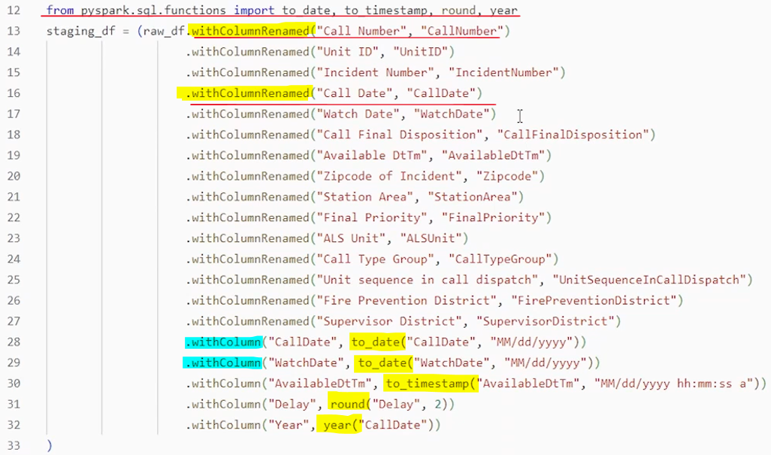

I'm doing a right format delta mode override at this volume location right in the files. I have created a separate directory for this data set and data is saved there. That's all.

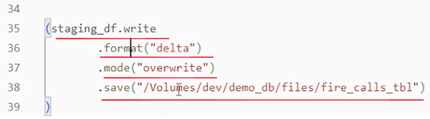

So we have the data. Uh, let's look at the directory data directory to understand how delta format data is is stored in the directory. So how do you check the delta table data directory. you can use percent s write percent f s LZ and go to the directory and try to list what do we have here. So what do we see here. We see one _delta log directory.

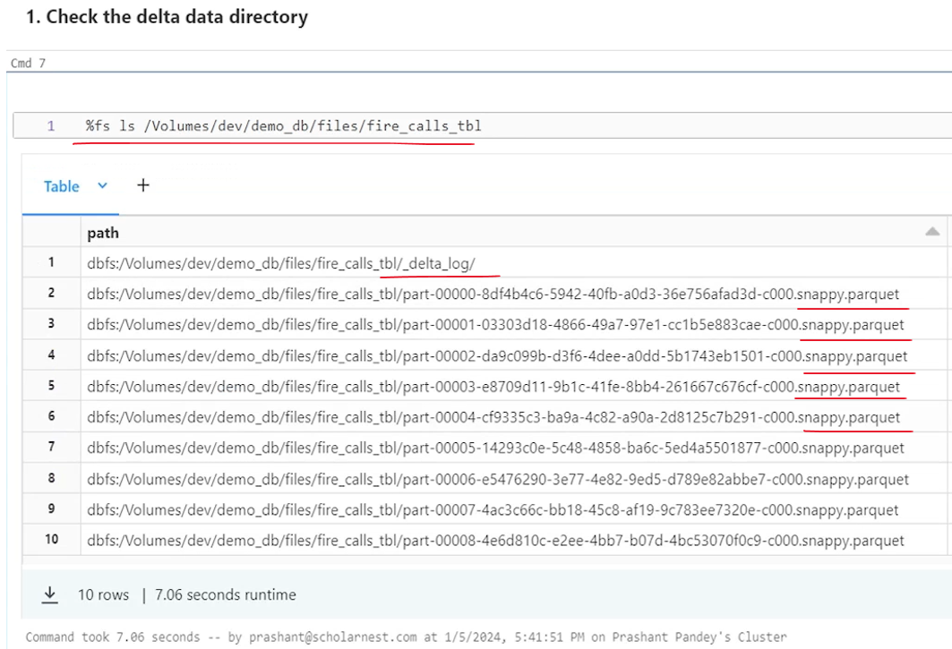

And all the magic happens inside this directory. So this is the directory which defines the delta table. Different versions of the delta table. We will go and look what is there inside this directory and try to understand that. But other than that directory what else do we have. Everything is like your parquet files right. It's snappy compressed parquet file. So all these I have ten rows here. So nine parquet files are there. So my data set is saved as parquet data file. And there is a delta log directory where some information, some additional information, metadata or transaction logs or version information. These kind of things are stored in the delta log. So that's what makes a delta table or delta format data set. This is all we have in the directory.

Now to understand it further we have to go inside this delta log directory. So let's go inside the delta log directory and try to see what do we have there. So percent f s ls and we go inside the delta log directory and see what do we have there. So. There is something temp path dir. Let's ignore that. And other than that, we have two files. Uh, dot CRC file and dot json file. A weird file name, right? Json file name is 000000 something. CRC file name is 0000 something. So what is CRC file? It's a. Uh, I guess cyclic redundancy check. It's a checksum which defines the, correctness of the data.

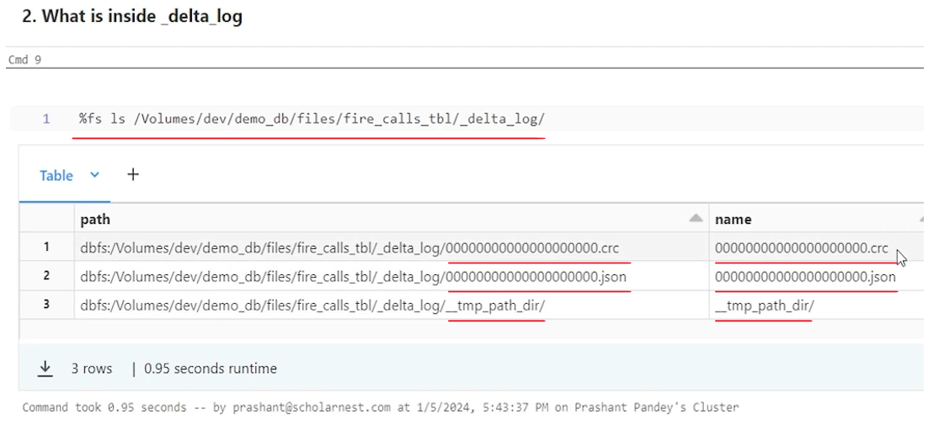

So we ignore that, but all the magic is happening here in the Json file. So Json file is stores some information about your delta format data set. And the file name is always equal to the version number of the data in your, delta table. So this file zero represents version zero of the delta table. Now let's do a delete operation on this delta table. Right. So let's do a %SQL and delete from this delta table or delta.directory name. Without a where clause delete is dangerous, so let me add a where clause here. So here is my where clause. So I am deleting from this delta table some records where this condition is true. Let's delete it. So delete is complete and it impacted 843 rows.

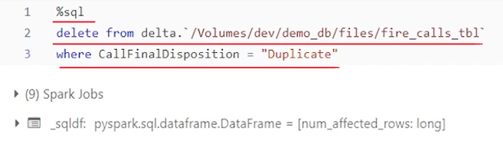

Now let's go and look at the delta log once again for my table or for my data set. So we come here and look at the delta log once again. And now I can see. Version one dot Json and version one dot CRC. So version 1.CRC is a checksum for the version one data files, and version one dot Json defines what is version one, how we arrive at the version one. All the details are here, so we will go inside the version one.

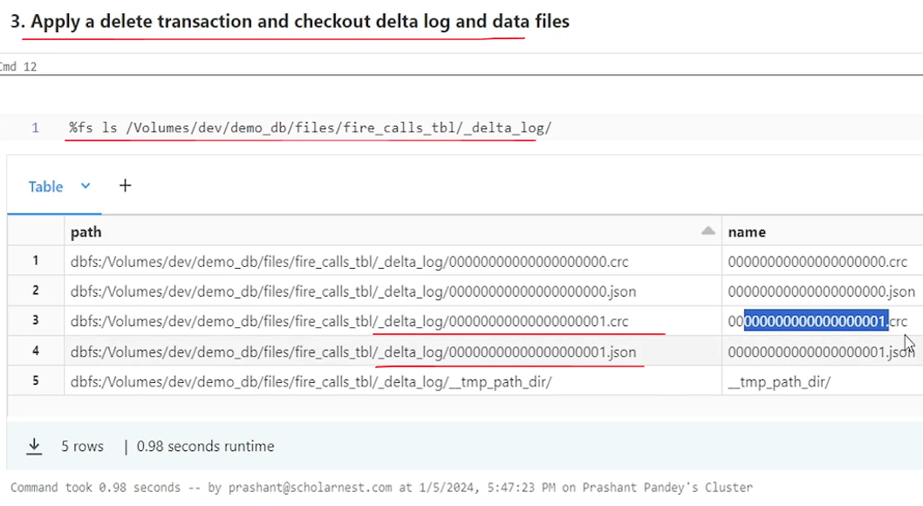

But before going inside this Json file and try to understand what is there, let's list the. Delta table directory once again, so I'll simply do fsls on the fire calls table. So let's see 15 rows right.

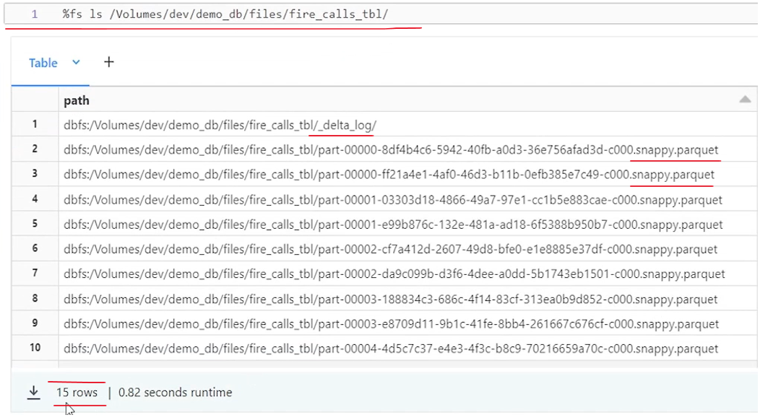

I did that list initially here. Right when we created the Delta table, initial and I saw ten records. Ten records.

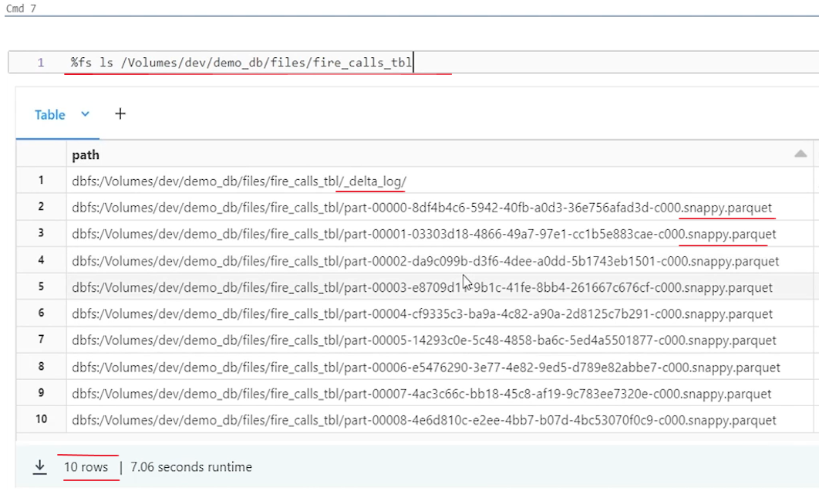

One is for delta log directory, and we had nine parquet files. Right. So my data was stored in nine parquet files. Now what I did on that. I. And this was the version zero. Right? And then I did the delete statement. And after delete I deleted 843 records. Right. And after delete, if I again look at my files now I have 15 rows. So you leave one delta log directory. I have 1514 parquet files. What is happening? I mean, I had a data set. Maybe 10,000 records were there that was made up of nine parquet files. I deleted 843 records. So either I should have saved nine files modified or I should have less files. Maybe some data is deleted, but how come nine data files are now changed into 14 data files? Right.

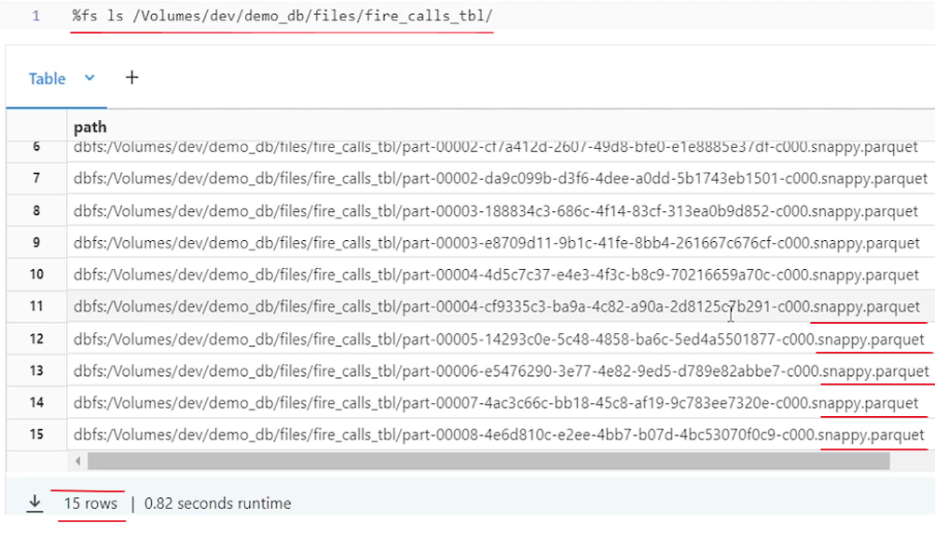

So now total we have 14 data files. So out after nine, five new files are created. I'm not inserting data, right. If I insert some more records, some more data into that table, I can expect that some new data files will be created. But I'm deleting. And still I see five new data files are created. So what is happening? How data delta table works. What what delta table is doing. So to understand that we will have to look at the. Json. For version one. So can we query this Json? Spark is super smart. We can do SQL directly and to on a table select star. From. Json dot and then pass the location. Right. So in this. Directory I can go to? Maybe. Delta log directory. And then inside that delta log directory I can look at the Json one dot Json. So one.Json is for transaction version one. Delta table version one.



If if you have a doubt you can do the history right. So let's do the history on this delta. Table. Um. On this delta table. Let's do the history. Um, percent SQL. Describe. History on this delta table. And we see version zero. Version one. Version zero was initial data right and version two, version one is created after the delete operation. So we have two versions and that's why we see two Json files here.

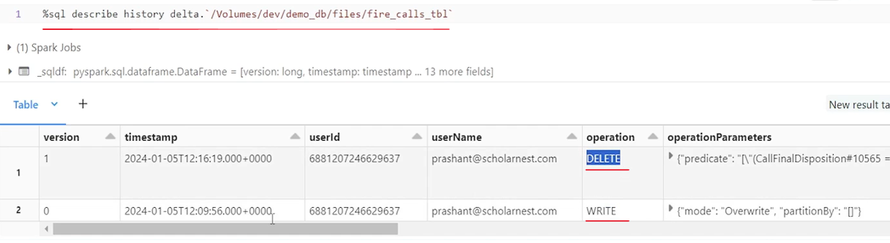

Version zero Json file defines what is version zero and Json 1. Json defines what is version one and that's what we want to understand how it defines version one. Why I got four new five new files created out of nine old files, for a delete.

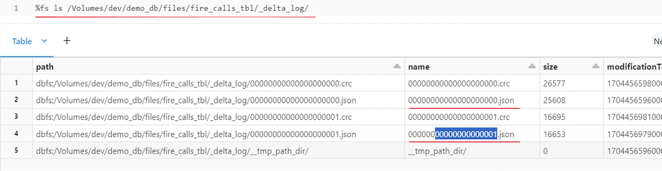

So let's try selecting this, and this is how the Json file data looks.

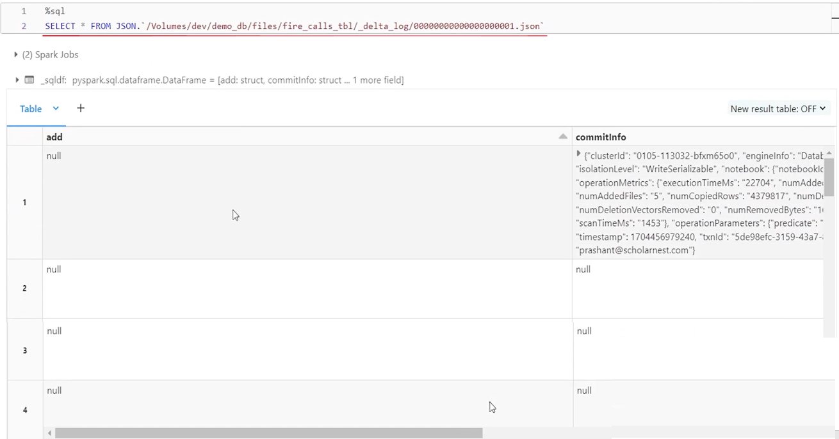

So we have an add column, then some commit info and then remove column. And that's all for now. For this transaction, for every transaction, Json file structure may be little different. but this is the typical, structure. So I have add column and I have remove column. So how many records are there in the add column. all that is null. One, right? One.

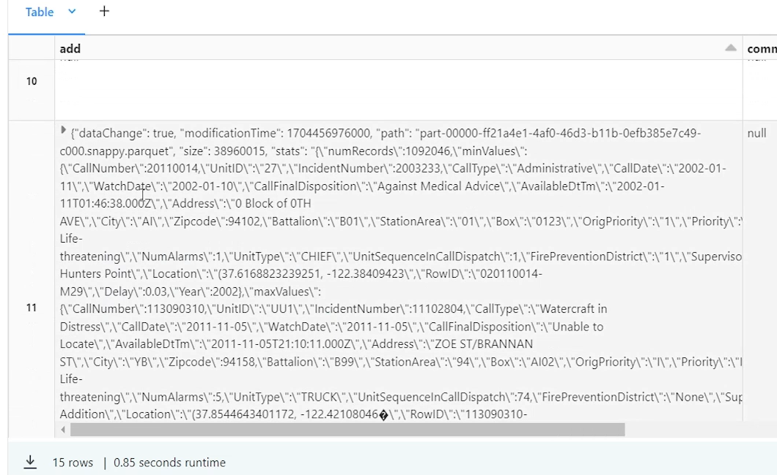

Are two, right?

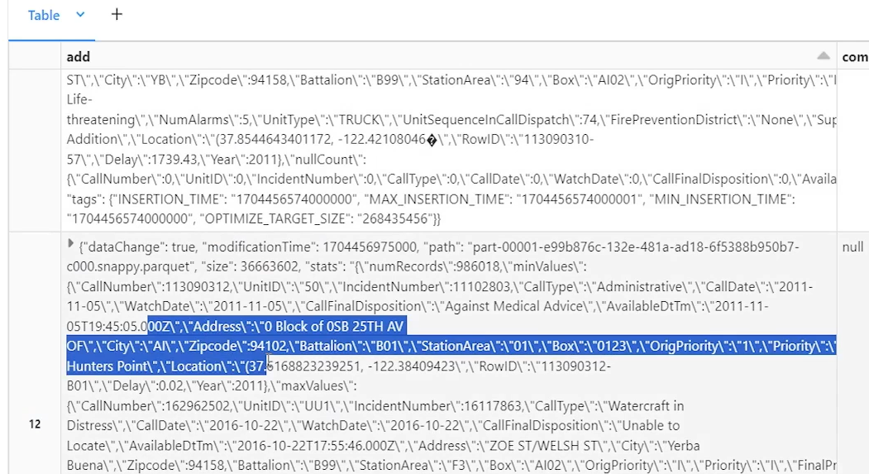

Three. And four and five five records for add column. And what are these add columns.

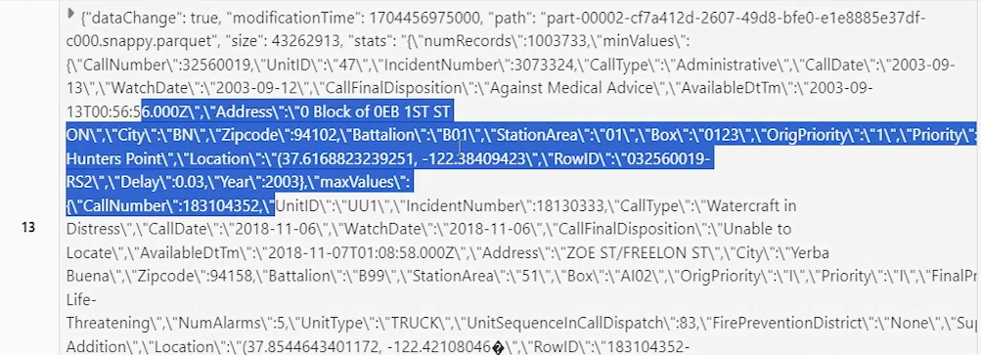

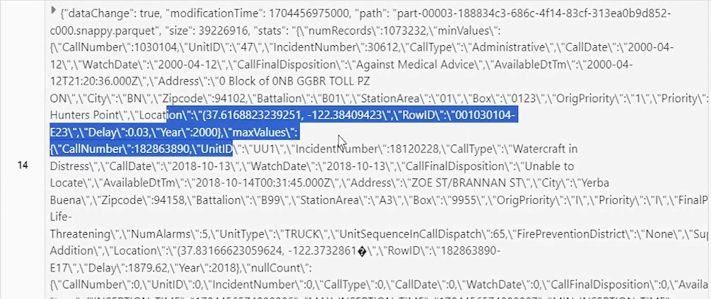

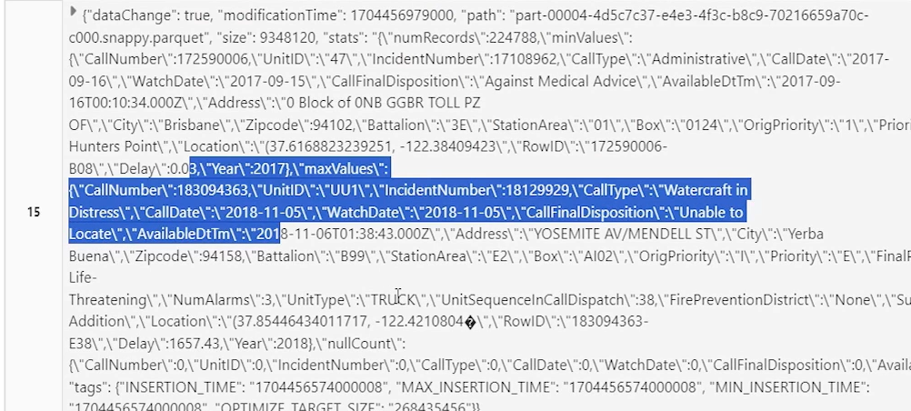

It is saying This is the new file. Which are added for version one, right?

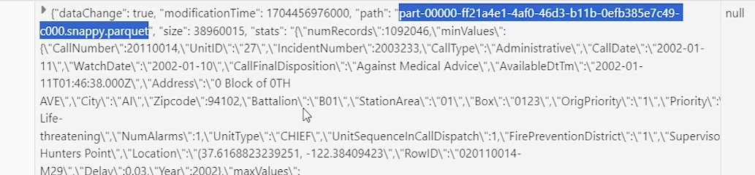

Similarly, these five records in the add column, they represent five new data files that are added for the version one. For version zero. I had nine files for version one. I did the list and I saw, 14 data files. So five files were additional. And that is what defined here. These five files are created for version one. So when we want to read version one we will have to read these five files. and what is there in the remove. So in the remove we have some files listed here also. Right. So how many remove are there. One two . . .



9 files are removed.

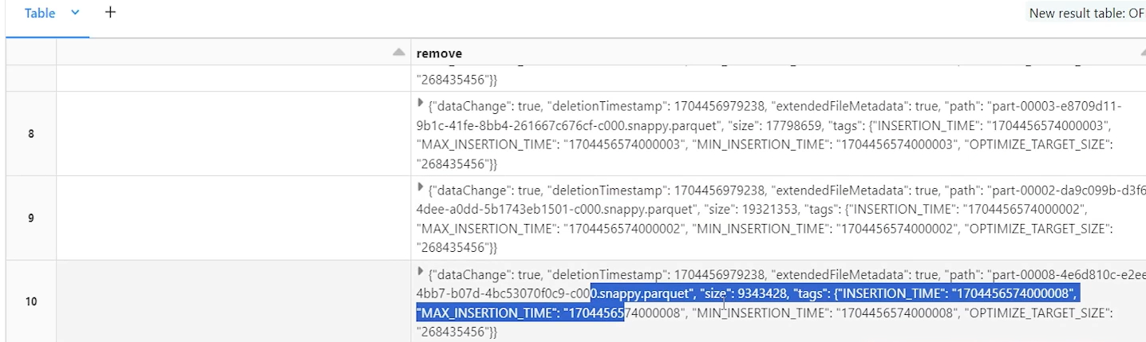

So. What are these nine files? These are the same nine files for version zero. So what? This one dot Json is defining one dot Json is defining that if you want to read version one. Read. All the files from the directory. Make sure you are reading these five files and you are not reading these nine files. Difference is the five files. So for version one, read these five files. And do not read those nine files.

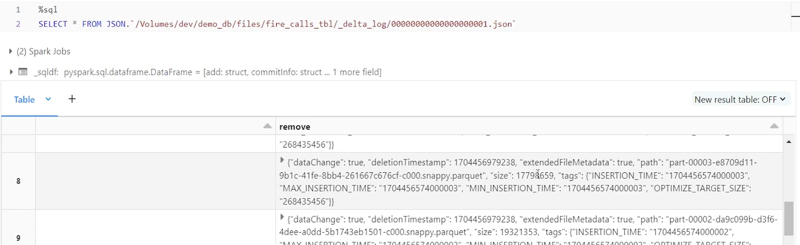

So for each version, delta table is recreating the data set. Why? What I did I had a table and we had nine data files. I wanted to delete some records and 843 records were deleted. So what Delta table will do? We'll go look into the data files, try to read all this data files and find those records which we want to delete, which are matching with my wear condition and delete those. So delete those and whatever is the result. rewrite that result as version one. That is what it is doing.

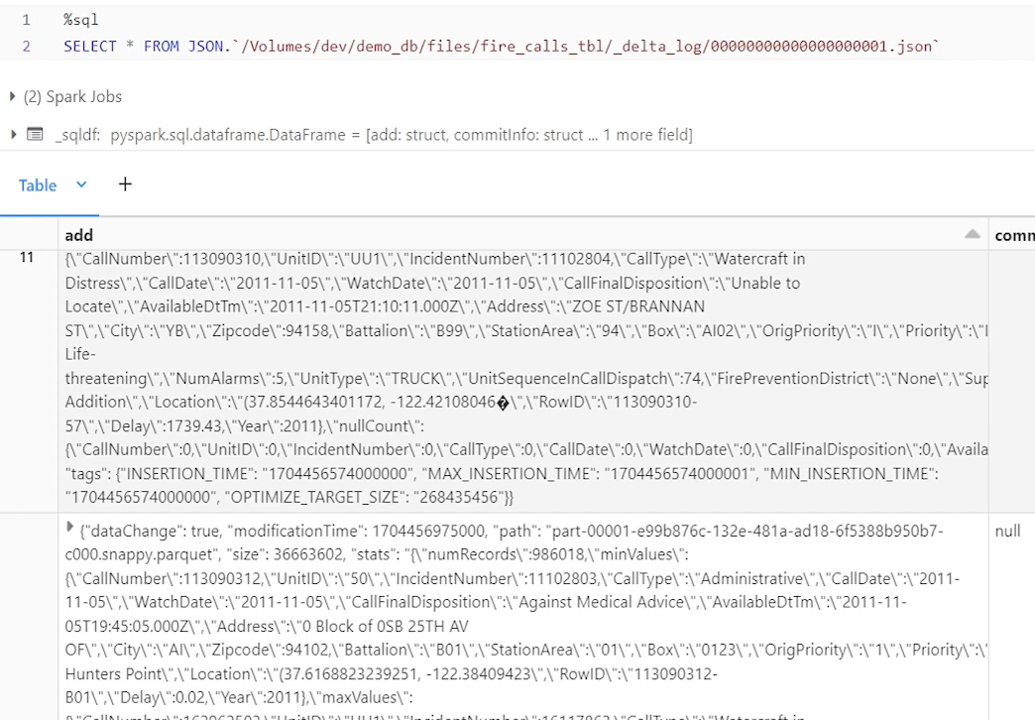

So deletion also reads old data set, removes the deleted records. Rewrites the new records as new data files. If you are doing update that also does the same thing. Read the previous version data set, update the records in the memory and write the new versions of data set as new data files. So every transaction is writing some new data files. It is possible that some old data files are not impacted. I want to delete some record. And my where condition is like that, that, out of nine files, only, three files were impacted. So my records that I want to delete were found in only those three files. So what it will do, it will rewrite those three files after deleting those records. Remaining six files will remain untouched and accordingly, this Json file will have the information that if you want to read version one. these are the new files added for this version. These are the old files removed from that version and everything else which is, untouched.

So read all those files and you can read version one. So that's how Delta Table works behind the scene. And that's what you can see in the delta log file. So one thing should be very clear in your mind that in delta table it looks magical. You can delete you can update, you can merge. But behind the scene it's not going and deleting specific records. It's always taking the data, deleting the data and rewriting the entire data set as a new data file. That's how it is doing. They do it in very efficient way, so it works pretty fast. But ultimately we are reading the file and removing whatever records we want to remove or update those records, which we want to update in that file, and then write a new data set. So every transaction on delta table creates a new data set, new data files. That's how delta table works.

### Delta Table Utilities and Optimizations

We want to learn some delta table utilities. we want to learn two three utilities and some optimization in delta table. So let's start with that. Let me go to my workspace and in my home directory. Chapter seven I have added one notebook for us to understand some data table utilities. So let me connect to my cluster. . Do some cleanup as usual and then do some setup. So basically what I am doing I am creating dev catalog demo db database. I am reading some data from Databricks sample data set. doing some basic initial transformation, basically renaming some columns and applying some, data type conversions to some of the columns, calculating some extra columns, and then writing it as a delta data set in this table.

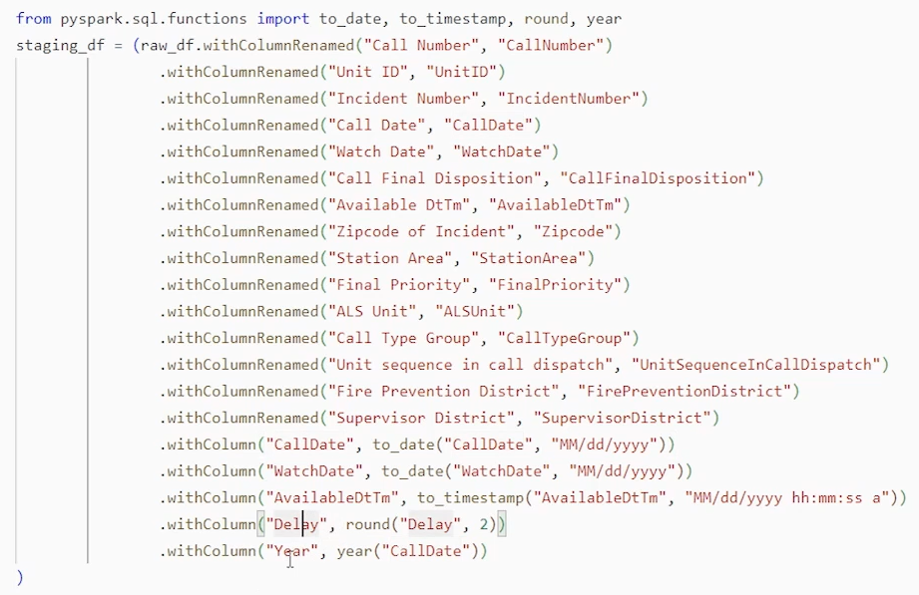

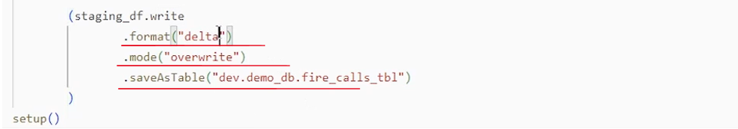

So basically I have a fire_calls_tbl Delta table already created. So we have a Delta table and we want to learn some delta table utilities with the help of this delta table as an example. So first thing, the first utility that we want to learn is vacuum utility. So what is the vacuum utility. What is the purpose of the vacuum utility, to understand that use case. Let's go step by step. What is vacuum utility and why we use what vacuum utility. That is what we want to understand when we use vacuum utility. That's what we want to understand. But for that, let's go step by step. first thing that I want to do is describe extended, table, this table, this is my delta table. I want to describe that table, using describe extended. So describe extended and give the table name and figure out some details about the table. So I'll go down and look at the location where this table is stored. So this is store table is stored in the meter store root container in my storage account in my Azure account.

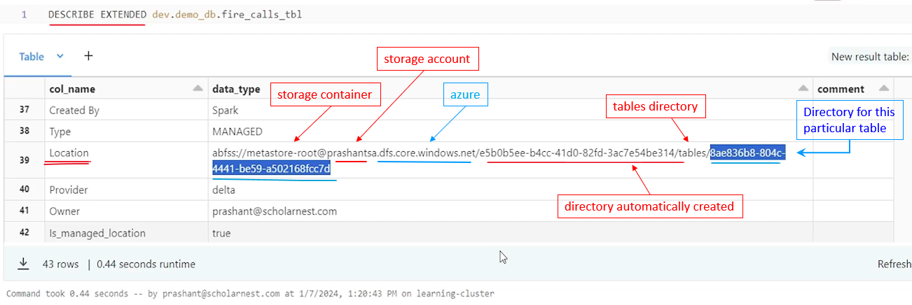

And inside that container root there is one directory automatically created by Unity catalog. Maybe this is a directory for the database. And then inside that directory I have a tables directory. And inside that tables directory this is the directory for this particular table. Fire calls tbl all that is managed by unity catalog internally. And the storage layer. So these weird directory names are there. What I want to do. I want to look at the data files for this table. I cannot access this location directly from, here. From my notebook, without creating an external location for that. It is secured location. I cannot access it directly from here, but I can see that from my Azure account, right? I own that directory or that container in my Azure storage, so I can definitely go and look at it. So let me go to my storage account. And this is the storage account where this directory is created. And in the storage account I have this meta store root container.

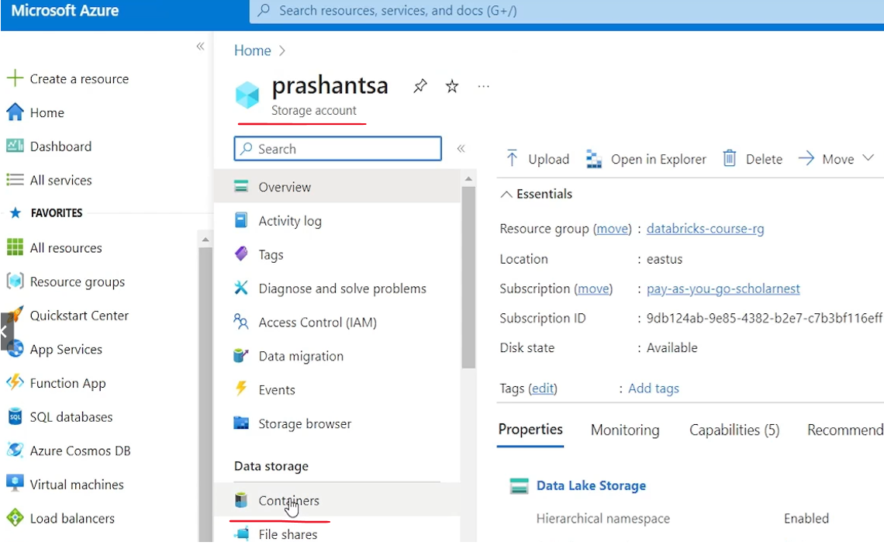

So I'll go to container and meta store root container. And inside that we see a directory B314. So possibly this is the one. B314.

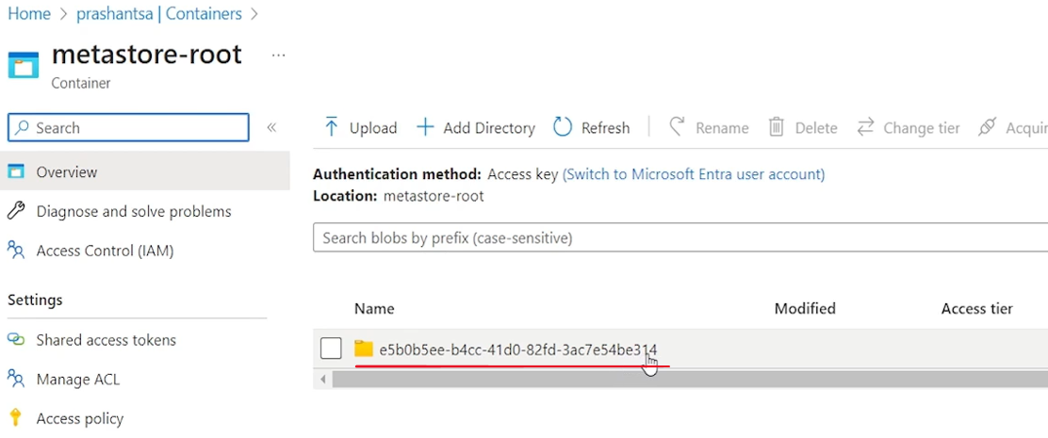

That's the directory for maybe database or catalog. We go inside that and we have a tables directory.

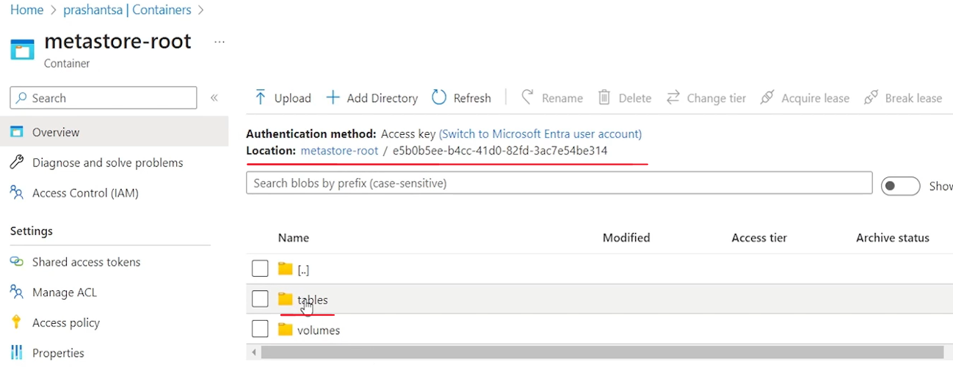

And inside the tables directory we see a bunch of things. So which one is my table.

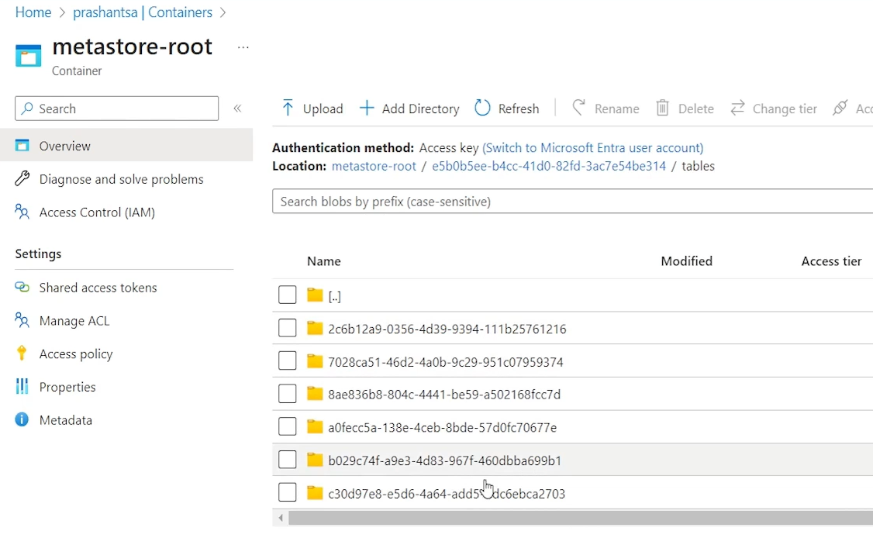

Let me copy the directory name from here and search for it. So this is my tables directory. That's how I could locate it.

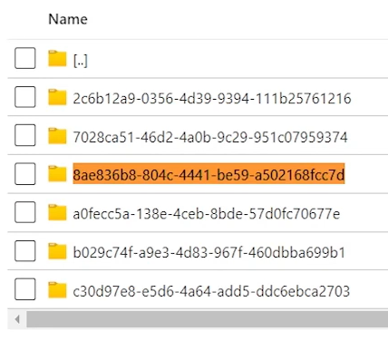

Let me go inside. And then inside I can see one delta log directory and a bunch of data files. Right.

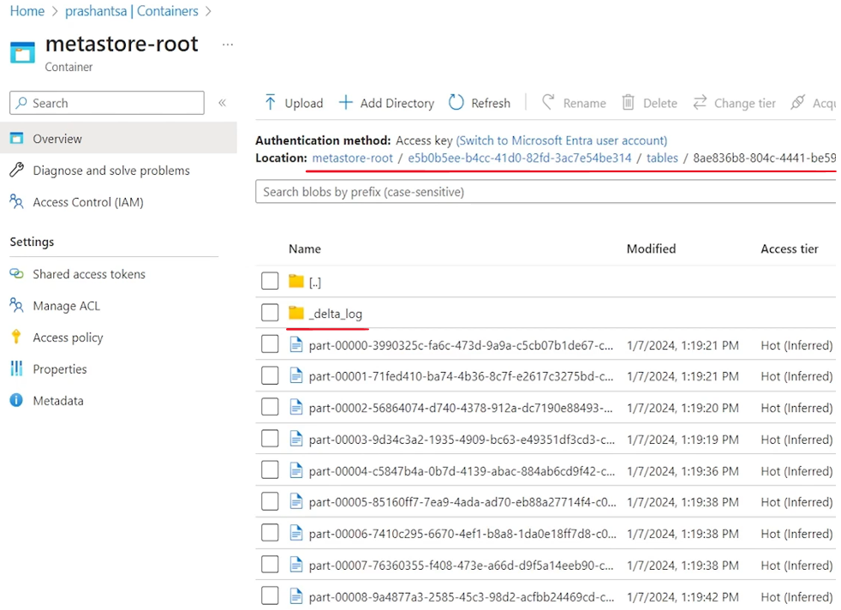

These are all parquet data files. 9 data files are created. So that's what we have. That's how my data is, is stored for this delta table. Right. Now. I have a delta table, and most likely we will be doing some transactions on that delta table as part of my project. Maybe updating some records, deleting some records, merging some records, all those kind of transactions I'll be doing. So let me simulate some transactions. So, I have a. Delete statement here. I'll copy paste what I want to do. Delete some records from this delta table and where call date is this. Right. So let me delete it. I have deleted I'm going to delete some records, assuming that it is part of my project requirement on that delta table. So I have deleted 597 records.

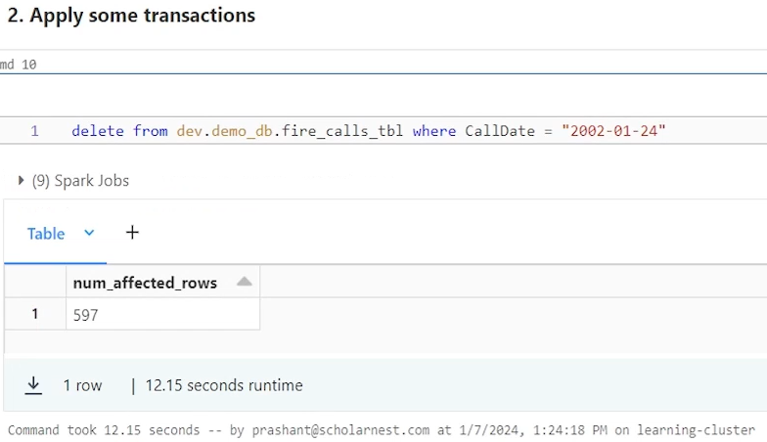

Let's do one more transaction. And this time I want to. Update. The entire data table, , without any where condition. Basically what I want to do. Update the delay column with an int value of the delay column. So maybe delay column is a decimal value. And I want to ignore the decimal part and update the entire table with only the integer part of it. Whatever. We have a requirement, assume that we have a requirement and we are doing some transaction on the delta table. So let's do that transaction.

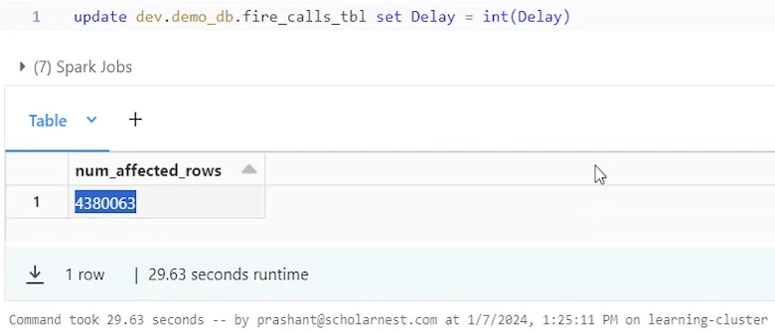

And once that transaction is done, I know. Delta Table maintains a complete history of all the transactions. Right. So let's describe history. History on that table and hopefully I will see three versions. Version zero okay, these many records are updated. Version zero. When I initially created the Delta table one one when I did the update, and version two when I did the delete. So as expected, we already learned all that. I see three versions of the table, right?

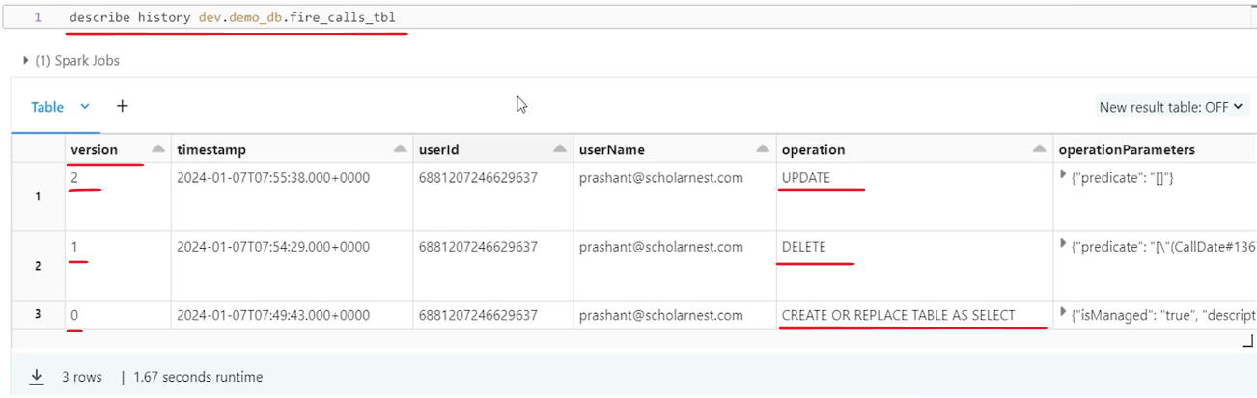

And I also learned that in Delta table, whether we do delete or we do update, it will create new data files right? For each version. It will create some new data files with the modifications implemented for that version. So if I come here, initially I had nine files. I did refresh, and I can see maybe some more files are there. Right. So how many are these? 15. So now I have 15 data files. And why 15 data files or why more data files? it started with nine. And why we have more data files.

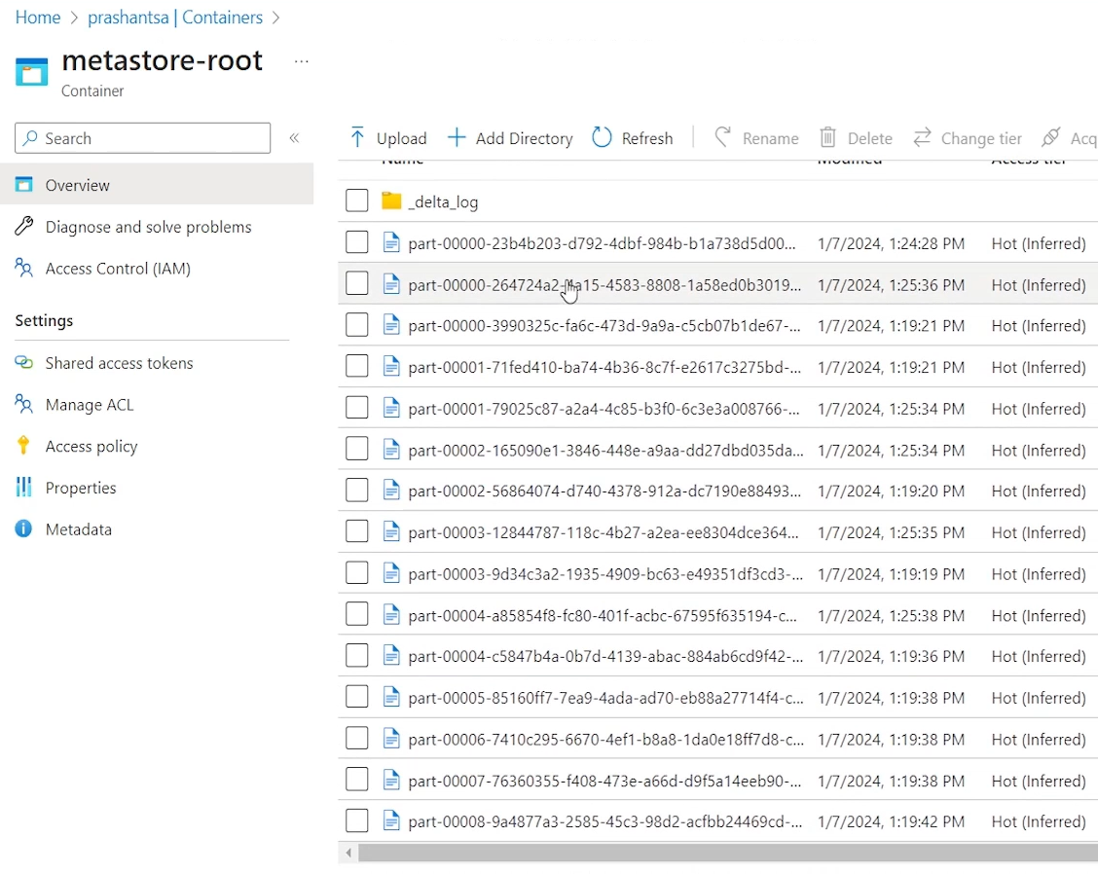

We already learned that in the earlier lecture. Maybe delete has modified some data. So new data files are created. Update has modified some data. So new data files are created. And what is the use of these old versions? I can query my old versions, right. I can write, , a SQL query. I can generate reports as on some point in time or as on some older versions.

So let's do an example for querying the old state of the data. So let's say this is the query select star from that table version as of zero where call date is this. So this is the condition for my delete statement here. Right on version zero I deleted these, 597 records, on the version zero, and we got version one created after the delete.

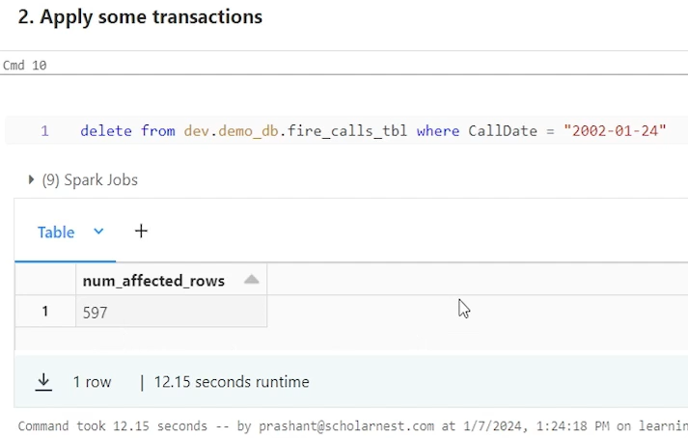

But I want to access those deleted records again, for whatever reason, for some business purpose, so I can go and query version zero of the same table and look at those records, with the where condition on call date. This. Right. So 597 records, which I deleted earlier here, 597 records. I can still access them from the version zero. Right.

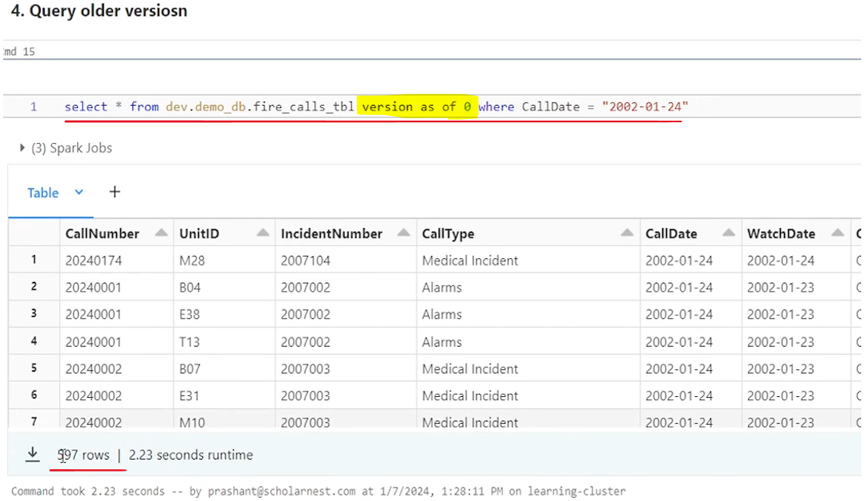

That's the purpose of having multiple versions or older versions. but how many versions? How long do you want to maintain all those versions of your delta table? You keep on maintaining that versions, infinite number of versions. you will end up creating infinite number of, delta table files. Right? Data files. it consumes space. that's a problem.

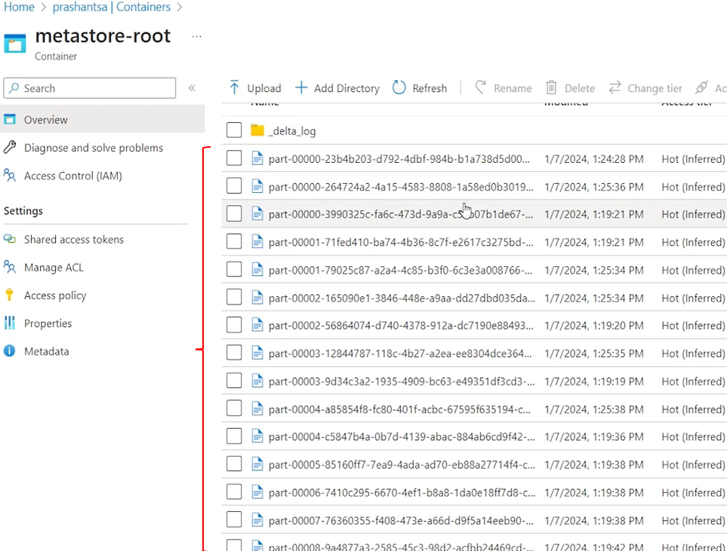

Space is cost or there are some regulatory requirements. Right? Maybe I deleted these, records because of some regulatory requirement. if the older versions are still available. We can access it, but the requirement was to get rid of those records. Do not keep it in your system. So I may want to clean up my older versions. I may not want to keep them. So how do we do that? So point is straight. How do we get rid of older versions of your delta table, which you do not need? Right. So how do we do that? So that's where vacuum command comes in. Delta table vacuum utility is just a vacuum command. You can use that to clean up your older versions which you don't want. So how to give you a demo how it works. I want you to count the data files from the back end. So as of now, I have 15 data files for this table.

And, then try to vacuum the table with zero retention. So let's see how the vacuum command works. This is how the vacuum command looks like. Simple, super simple vacuum. And then tell the Delta table name which you want to vacuum. this is the Delta table name and you tell written, how many hours of data you want to retain. Right. And it also comes with a dry run which will not delete those old versions or old data files, but only report you that. What is the, what it is going to do? So let's say I want to, do a dry run and understand how many data files it is going to do, on this table. And I don't want to retain anything. We have three versions here, right? Zero, one, two. And I don't want to retain anything. I want to vacuum the entire table. Does it mean vacuum will delete the version two? Also, no vacuum is to clean up older versions, but latest version must be there, right? At least one latest version must be there. So vacuum will keep the latest version and remove the older versions. Which versions to remove will be based on this retention hours. So you can specify retention hours. Zero hours means keep the latest version. Remove everything 100 hours means keep all the versions which are created in past 100 hours and remove everything else. So like that you can do. So let's try to do a dry run because it is going to remove the files. So it's always advisable to do a dry run.

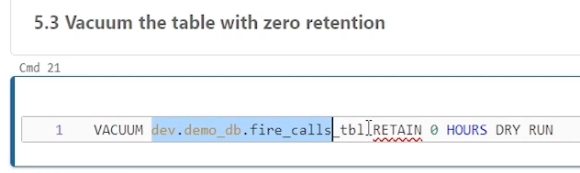

But it failed. Failed. requirement failed. Are you sure you would like to vacuum files with such a low retention period? It's a weird, ask. Right, I want to. Vacuum everything. Not even a second. Data only keep the latest one. Vacuum everything. Zero. Our retention is is is a big thing to do, a big decision to do. I want to do it for demo, but we have a built in safety check in Databricks platform. for such a low retention vacuum, it will always throw you an error. Are you sure? Be double. Sure.

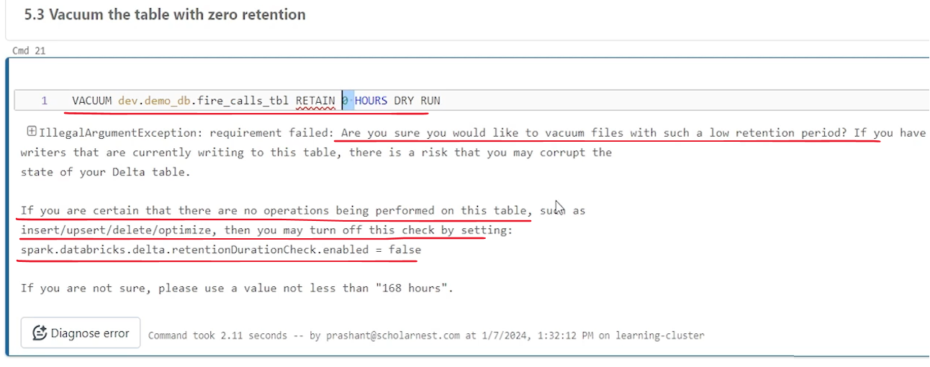

A default is 168 hours, right? If you are not sure, please use the value. Not less than 168 hours, 168 hours if you translate it into days, it comes around 7 days. So default retention is 7 days, which means recommendation is to keep at least seven days data. Old versions worth seven days and may be older than that. You can retain a vacuum or clean up and this guy will not complain. But. It is giving us a warning. How do I disable that warning? Okay, fine. You are like, thank you very much. You are giving me a warning. I'm not doing foolish thing. I have a purpose for doing that. I want to do it. So they also said that. Okay, you can set this, configuration to false, and we will disable this check. So let's do that here. And maybe I can use set command to set that configuration to false. So the Spark Databricks Delta retention duration check enabled which is by default true I want to set it to false and try, vacuuming everything with zero retention hours. This is applicable only if your retention hours are less than 168 hours or the default seven days. So let's try running it with the dry run. Okay, I have not executed this, so let me run this. And once it is disabled, I can try the dry run once again.

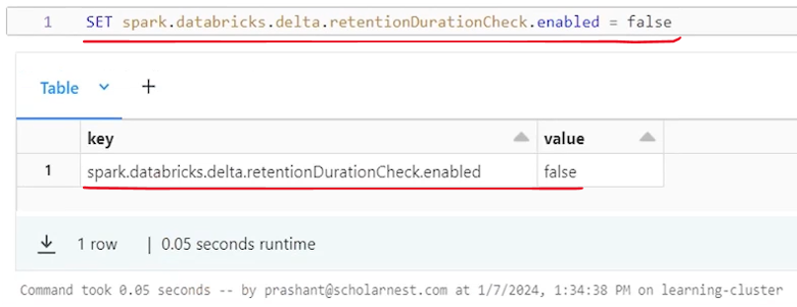

Okay, so it shows ten records here. So what it is showing that it is going to if you run this without dry run, if you actually run this we will remove ten files. Right. They will remove ten files from your data set. So let me remove this dry run from here and run the vacuum. Let's see what happens. Let's go with it. Remove the older versions. Keep only the latest version.

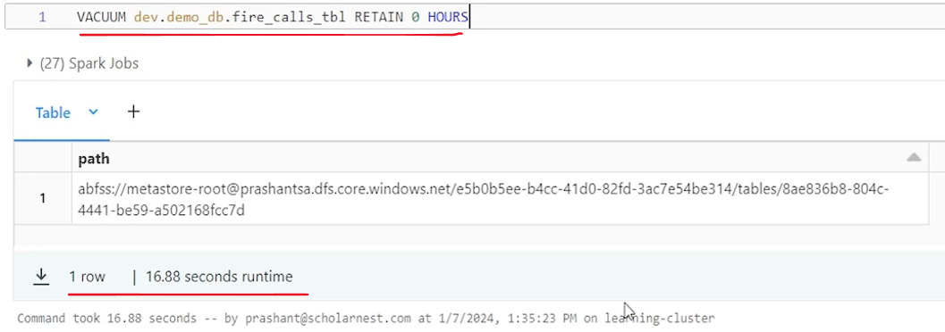

Done right. So let me keep the dry run here for safety. but we have done it without dry run. now, count the data files from the back end. It should have removed ten data files. we had 15 data files earlier. If you refresh. Ten files are gone and I have only five data files, so my storage is cleaned up, right? Unnecessary files, which I don't want to keep is cleaned up. Now. Since I deleted my older version. can I run this kind of query? As version as of zero. So obviously. It should not work. I'm trying to access version zero, but I vacuumed version zero. Version one. Both. I only have version two, so if I try running that, I should get an error. file read exception while reading this, that file not found, blah blah blah.

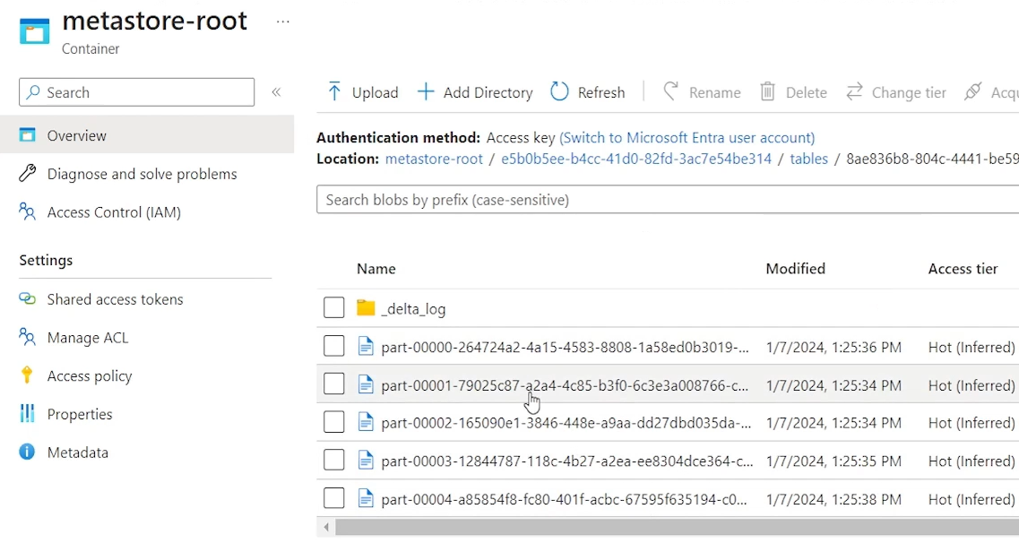

So the advantage of having a vacuum is that you can keep cleaning up your older versions of Delta table, which you don't need. A disadvantage is that once vacuumed, you cannot access the older versions, but that's the requirement in many cases. We may want to keep it for one month, and after that we want to retain, clean up our older versions. So if you have that requirement you can run vacuum commands. I hope you understand the vacuum command, its purpose and how it works.

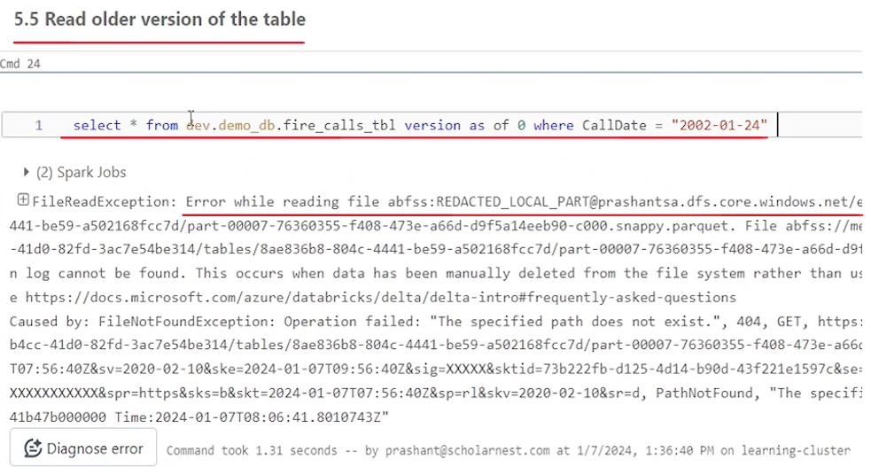

Now let's learn about the different utility. The second utility the second utility is known as reorg. So but to understand the reorg let's come up with a new requirement. Let's assume that you have a requirement to remove some columns from your table. I already have a table here. A table name is, . Fire calls TVL. It's a delta table. I want to drop some columns from this table. Can I do it? Maybe alter table. statement should work. So let me copy paste. Alter table statement for this same. . Here is the alter table statement. Alter table from dev demo DB fire calls tbl drop columns, and I want to drop these two columns from that table. These two columns are already there in that table. I want to drop it. So alter table statement should work. let's try it. It didn't work. A drop column is not supported for your delta table.

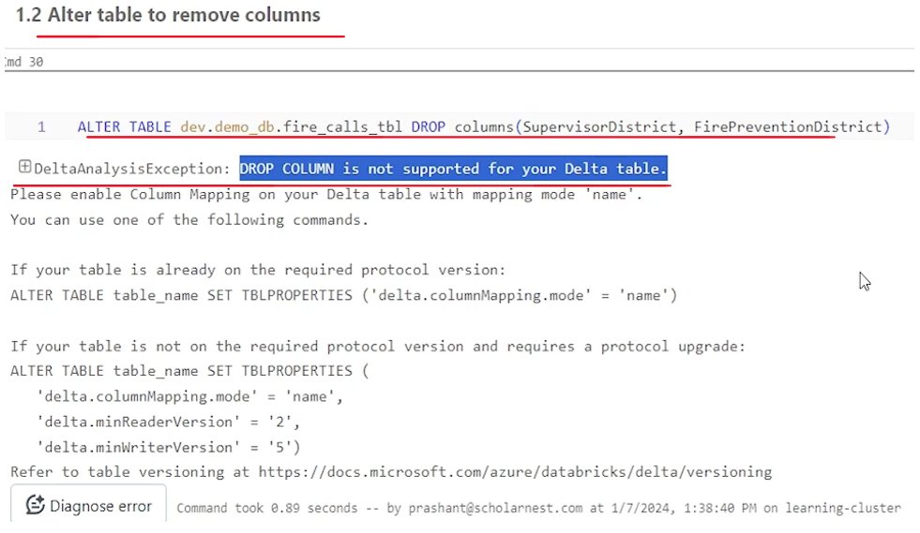

This is a feature which is available in some new versions of the Delta table. Maybe that is. By default, it is not enabled for all delta tables. I have the newest version of the delta table in my environment, but by default that capability, alter table drop columns capability is not enabled in the delta table. Why? Why it is not enabled by default. Maybe they will enable it in the future versions, but think about it. You have a delta table which where your data is stored in these five files. Maybe these are huge files. In my example, it's not very huge. I have like , maybe 100 less than 150 MB data, but you may have a huge delta table.

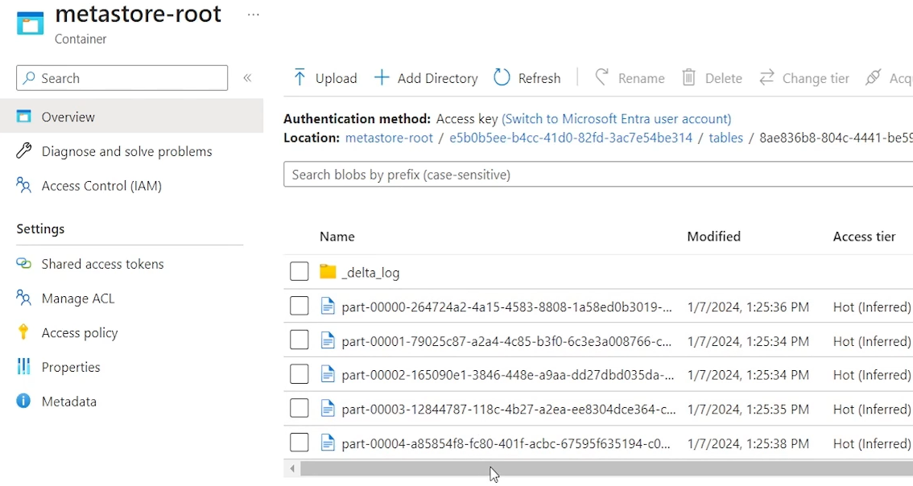

Your data is stored in these files, so you may have a lot of data. You have you may have a lot of, data files. Alter table, drop column. What does it mean? You want to remove data for two columns from these files. Right. And you also want to drop those columns from the metadata. So table is made up of two parts. One is table metadata which defines what are the columns are there in the table and the actual data where your data is stored. So if you want to drop two columns completely, those two column names should be dropped from the metadata so that when you do select star, next time you don't, see those two columns. And then data for those columns should also be dropped from the table, from the data files. So there is a lot of work to do for dropping columns, which could be a very time consuming operation for very large tables. And that's why this is not by default enabled, for time being, but that feature is available. So, that feature is available, dropping columns feature is available with some optimization. How to enable that optimization, you have to set these table properties on your delta table. So alter table table name set properties and you have to set these three properties. enable column mapping mode by name and min reader version two. Min writer. Version five. Simple. I'm hoping that this.

These features, these properties will be enabled by default in the future versions. but let's do that because we actually want to drop these two columns as part of the business requirement. So to enable but it is not allowing me to do that. So let me alter table, alter my table, set these two properties and then try to drop those columns right.

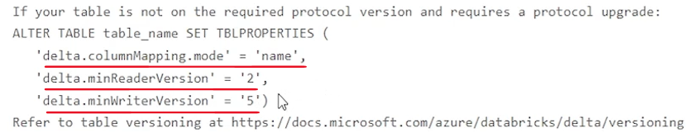

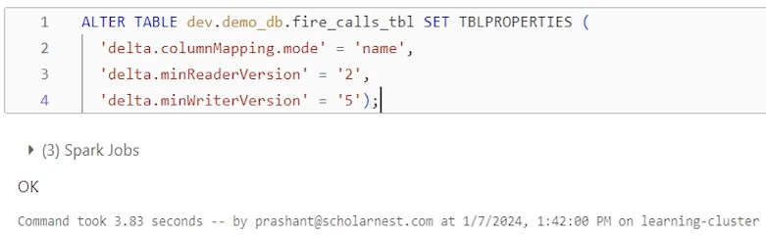

So you can set it on an existing table. No problem. So I have set that configuration. And now if I run this it will drop those columns. But what are these properties. What it is enable column mapping mode by name. What it means it is saying that okay we can take a optimized approach for dropping . Columns from an existing table and that is drop it from metadata. Remove those columns. Right. But leave the data in the data files. Don't touch the data files. Leave it as it is. Data is there in those files, but we removed the metadata. So whenever we do a select star, we will select only those columns that are available in the metadata. And even if some user is trying to access those two columns, we will keep that. in the record. We will mark those columns that these are marked for deleted. So we will not allow anyone to access those those columns. Right. So select supervisor district, Fire Prevention District from this table will not work because the column names are marked for deletion. So that is an approach that is an optimization they, have in place. And that optimization we have to enable manually.

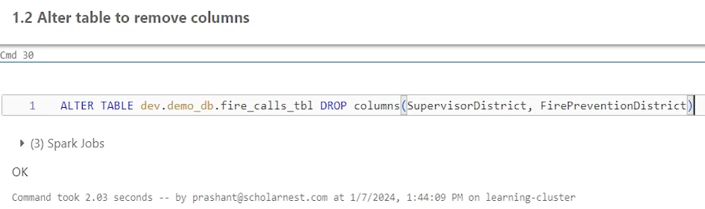

So that's what these properties are. We are enable them enabling them manually. And once we enable them then I can drop column. It will work like this. Because what it is going to do, it's just going to mark these two columns for deleted as deleted. it's not going to modify any of these data files and physically remove the data from these files. So let's do that and worked like, very quick. Right. And if you check the history after that, because it's a delta table, it should have the history and should keep a record of everything we are doing. Right. So let's do, describe history on that table. you will see, . Drop column created version six. even set properties. also created version five. And on top of that, we dropped the column and it, has recorded that supervisor district and fire prevention district, these two columns we are dropping. so that's how alter table drop column works. But. Let's say we have a regulatory requirement to get rid of those two columns.

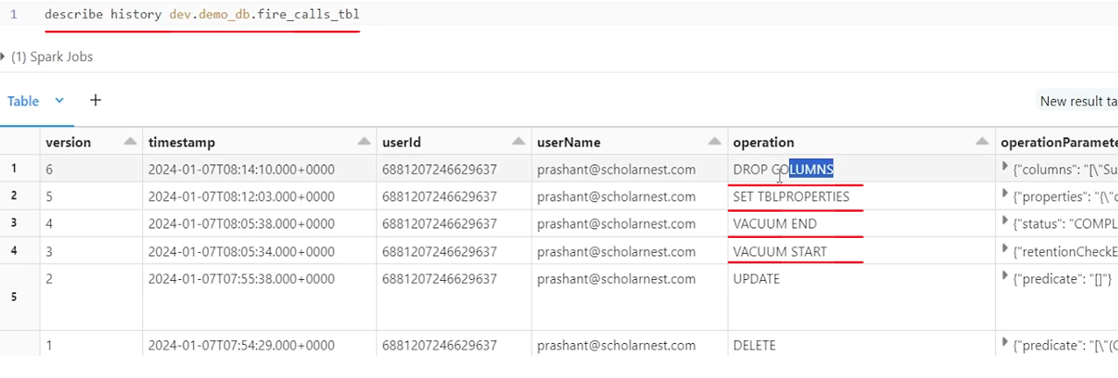

We are not supposed to keep those columns in our, record in our system, because of some regulatory requirement, we need to physically remove it, which is not done from these files. If you refresh this. We still have those five files because for drop column, these files are not modified. Nothing happened on this file. So basically in those files those column values are still there. But we want to get rid of it.

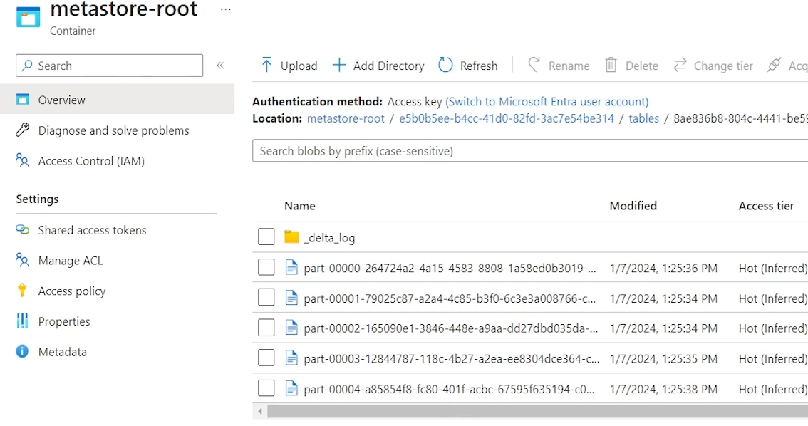

For maybe there are two possibilities. Two reasons for that. You have a compliance requirement, regulatory requirement to get rid of those fields. Or those fields are unnecessarily taking storage space on your, , storage layer. And you want to get rid of those files permanently and save some storage space, right. So how do you do that? maybe. That's where reorg comes into play. We have a reorg tool which will look at your delta table data files. look for what? all the things are marked for deletion later. And if you run the reorg, it will go and physically remove everything that was marked for deletion right later. So it will reorganize your data files, reorganize your, data set. once again, also implement some optimization maybe in the background, because it will read those files, remove the deleted columns, deleted values, column values and rewrite those files. So, but you can do it later when you have, bandwidth or resources or time to do that not as part of the project transaction. As part of the project transaction, you will do alter table, which will work like a charm, like quick and later in the background you can reorganize your tables. So how you reorganize work or reorg work? It's simple SQL statement.

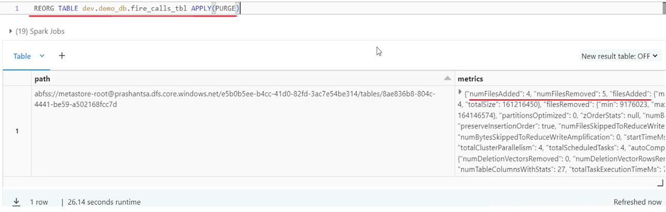

Simple reorg table. Name reorg table. Give the table name apply purge. That's all. So I'm going to run this. But before running this let's look at the data files here I have five files here. let's do the. reorg. And it's going to take some time depending upon your data size. Okay, so it worked. And what it says. Number of files added four. And number of files removed file five. So what it did these five files we had which are for the latest version, and it removed those two columns from these five files. So basically these five files should be removed and it has written new four files and that's what it is reporting. So it took those five old files, removed those two columns in memory and produced four new files without those two columns.

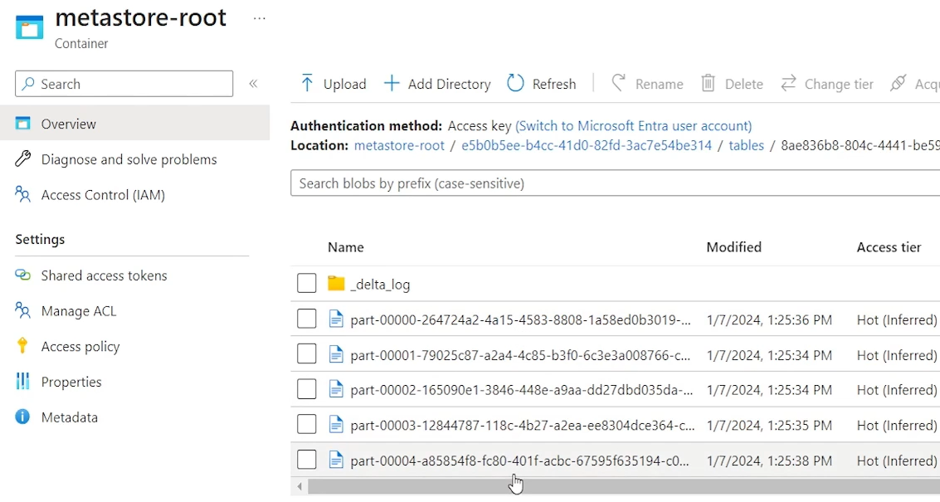

That's the reorg activity. So if I refresh this, I should see four new files. What about these five files? Let's refresh it. So these five files are still there. They are not permanently removed. They are not part of the latest version.

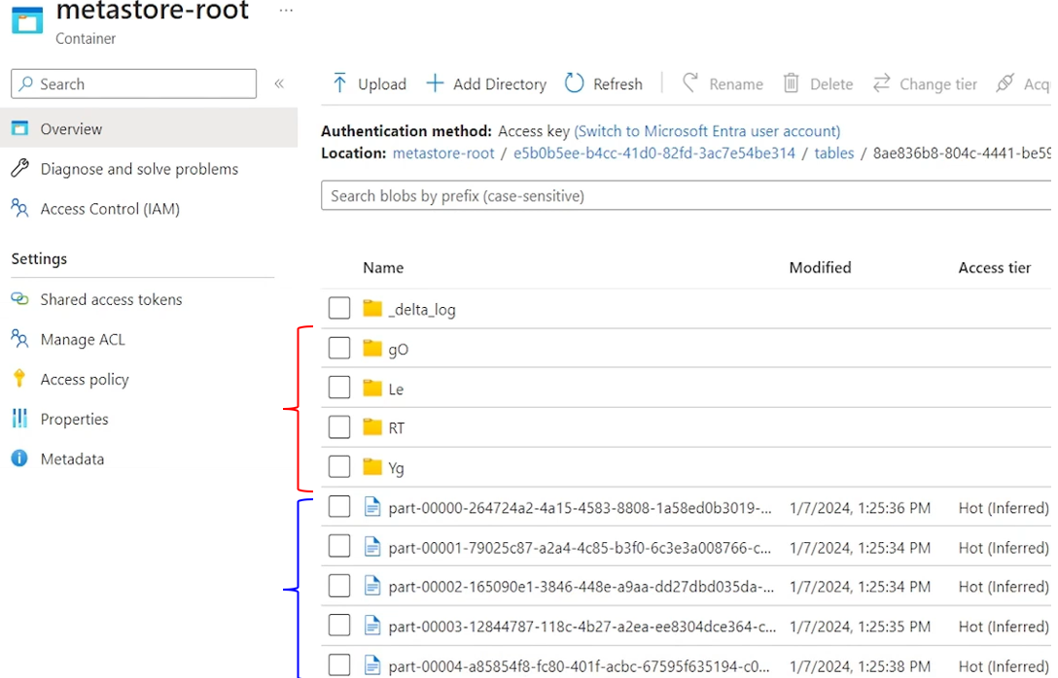

So what it means if you look at the, version of your table once again. You will see version seven, which is created as part of the reorg. Version six is as part of the drop column, so version six also exists. Version seven also exists, right. And that's why these five files are still kept there as part of the. Version six files. Where are those four new files that reorg has created? Or maybe due to some reason, how they implement. They created a directory, and in those directory they created these delta files. So maybe you can see four directories with some random names.

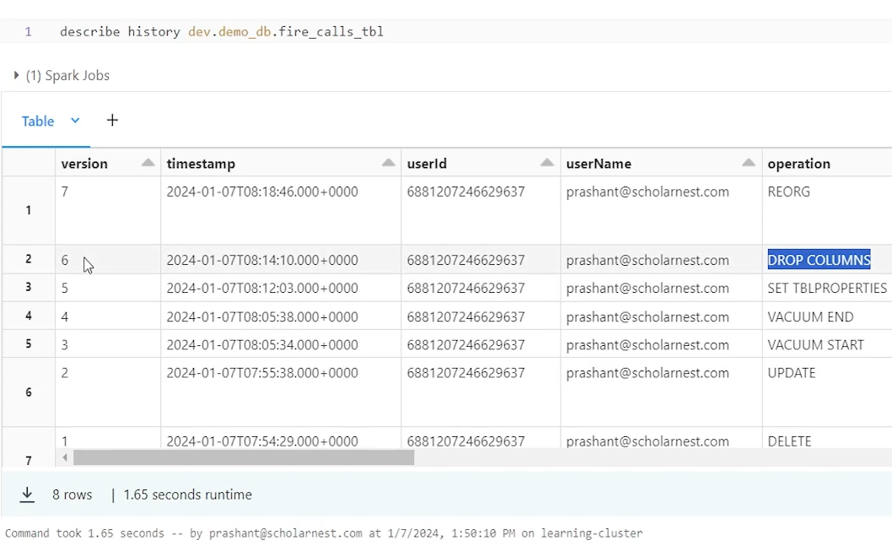

And these data files are kept in the those four directories. Right. So all four directories has got one one file. that's what it is. Maybe for some technical reason, the new files after reorg are created into subdirectories, randomly generated subdirectories. But we we get this sense right. Reorg has marked all these files as version six files. And these new four files as version seven files, which is created after reorg. That's what the reorg does. ideally if you are doing reorg you are. You want to physically remove those columns that were, , dropped? you should be doing vacuum also at some point of time. So what if I do the vacuum once again after the reorg, right. reorg, vacuum retention, zero hours. Let's remove the dry run and dry running it. So keep the most recent version and everything else remove it. So in that case. The vacuum should remove all these five files, because these are older now.

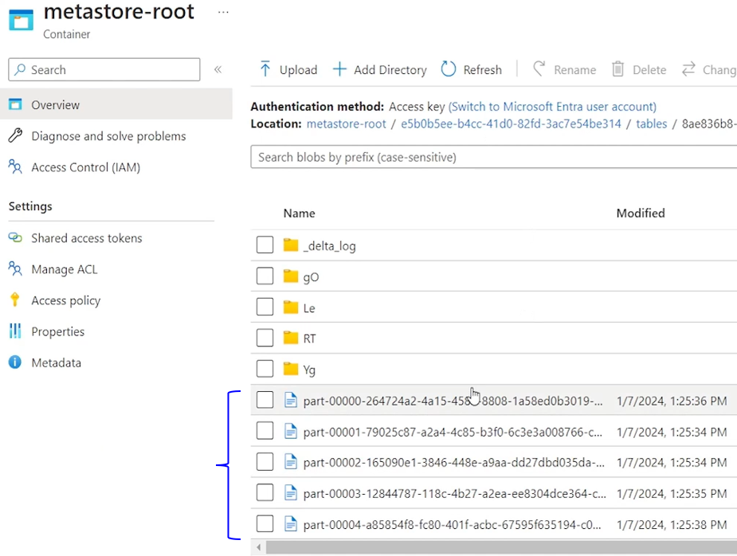

So. It is running. I'll just keep this dry run here. And then we got some output here.

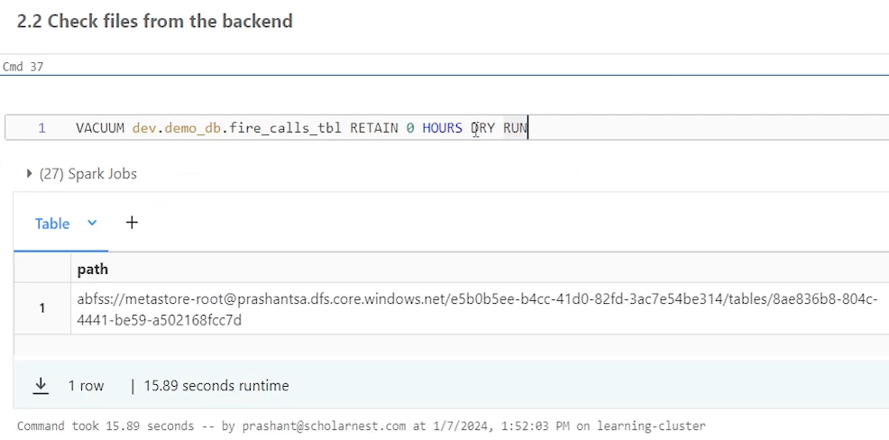

So let's refresh this. . All those files are removed, vacuumed. Right.

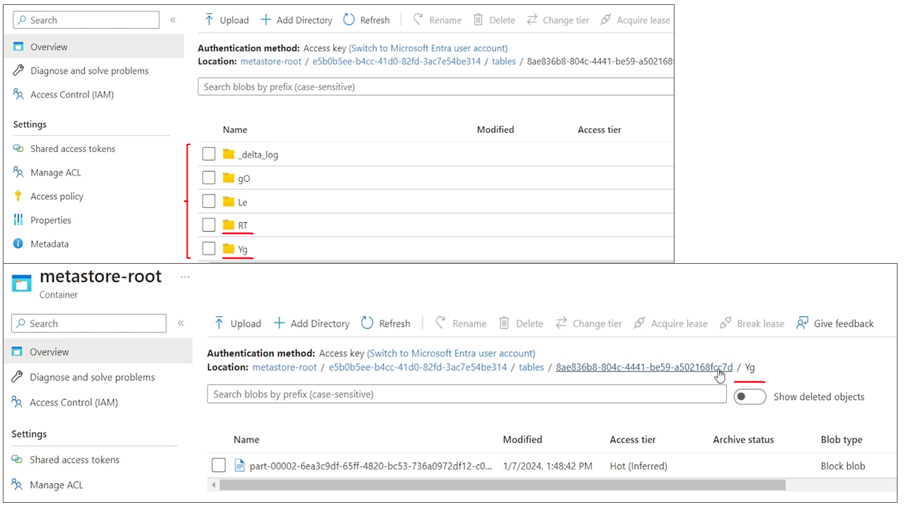

And my data files are here. in these directories, after the reorg, those are still there. Right? So all those are there. And I can see four directories here. So that's all about the reorg. Reorg is used to logically deleted or records or columns. Things that are marked for deletion is used to physically remove them and create a new version of the data set after removing the marked for deleted things. That's what the purpose of the reorg. And usually after reorg, if you really physically want to remove your old, data set files, you should be doing a vacuum also.

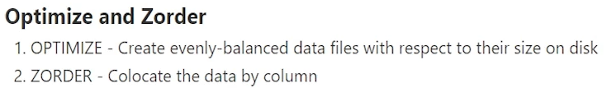

Now, the last thing that we want to learn is optimize. And z-order. So optimize is the next utility or delta table tool offered by Delta Lake. And Z-order is an option which can be done after the optimize or along with the optimize. So what is optimize? the purpose of optimize is to create evenly balanced data files with respect of their size on the disk. So basically, , when you are creating data, when you are ingesting data, collecting data, maybe you are collecting it in batch or you are collecting it in a streaming. you are saving data, writing data into your delta table. And there are different frequencies, maybe every second, every minute, every 30 minutes, every hour. You are ingesting collecting data in all that it it is very likely that you will create a weird kind of, data files because maybe you are ingesting something in a streaming every, , one minute is your streaming trigger, and every one minute you are saving some data into the table, creating a small, small files.

So and we know that small files are big problems for spark. , spark has to open too many small files. Close those files. A lot of time goes in listing those files, opening those files, closing those files, which is an unnecessary activity. So it is recommended that you come up with the decent size of files. Your files should not be like one KB two and be three MB five MB be have at least , a decent size of files. The recommended size is 128 MB. That's the default setting. In some of these spark configurations. So but what if you have created your small small files or uneven files in your delta table due to various reasons? can we optimize it? That is where the optimize command comes in. So if you already have a delta table, you leave it for maybe a month. , or maybe a week. Let all the weird types of, files sizes get created, and maybe on a regular basis on weekly or monthly basis, you do the, optimize once to fix whatever problems you created till then. So that's where the optimize command comes in. So optimize command will create, recreate, read your existing data files which are not yet already optimized, and recreate evenly balanced data files with respect to, file size on the disk. So that's the purpose of optimize.

And Z-order is an option which you can use along with optimize to co-locate data by column. It's like we sometimes, do our, delta table or our tables partition by some column. Right. Why we do that? Because we want to co-locate data for that partition, into a separate directory and take the benefit of partition pruning. Right. Similarly, there is an option in Databricks or delta tables, while you optimize, you may define some column. Okay. These are the columns which I'll be querying most frequently, or maybe these columns, which I'll be, interested or I want my data for these columns, same, same value of these columns. All the records should be kept together since you are recreating data files. Let's do that also. Right. So Z-order is an option with optimize command, which will try to co-locate your data for the given columns while recreating those data files.

So let's see how to use optimize and Z-order. it's a very simple SQL kind of statement. So let me paste the code here. So what I want to do optimize my. This data set and also z-order by year and call date. I want to keep , 2022 year data together or closer. , and then maybe by call date, for the entire year by call date. Also, I want to keep it sorted or closer together because I know that's what, my requirement is on this table. In the future, we will be reading data mostly by year and call that call date.

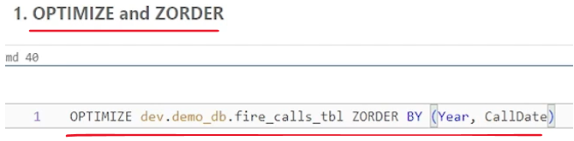

And I have not done partitioning on these columns, so. But still, I want to take some performance advantage, by doing z-order on this column. So that's what it will do. So before I run it, let's look at what do we have in our, directory. So I have four data files. they are spread in some randomly named directory due to reorg if I go to one of it. maybe file size is 45 MB for the first one, I come back. Look at the second one. A file size is 33 MB. looks like, almost evenly sized. 35 MB. Right. But still, the files are small. 30 MB, 40 MB range. ideally, there should be somewhere close to 125 128 MB. So we have a scope for running a optimize here.

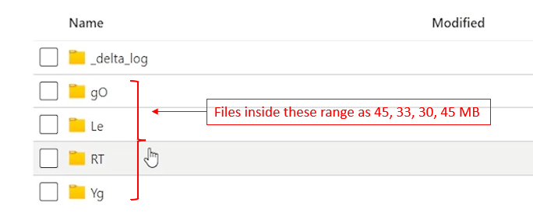

So let's do the optimize. And then we will see what optimize has done from the back end. So let me run it. It's going to take some time because it will rewrite the data files up after optimizing those data files. It is done.

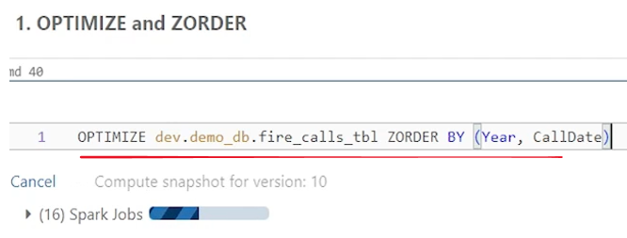

So what we see here, num files added to the result is two files out of four and num files removed four. So what it has done, it has created two files and removed Four files.

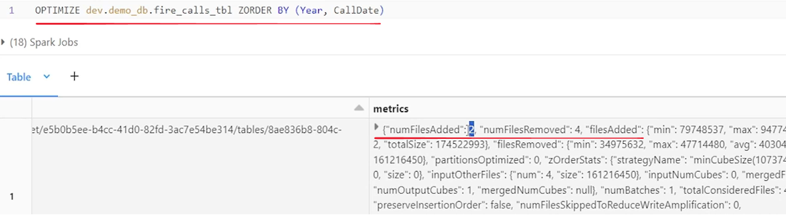

And let us go back to our directory and see what it has done in terms of files. so okay, so I see six new directories now. sorry, six directories now. And maybe four were already there. Two new directories are created. So it looks like, optimize is also putting data back into some randomly created subdirectories.

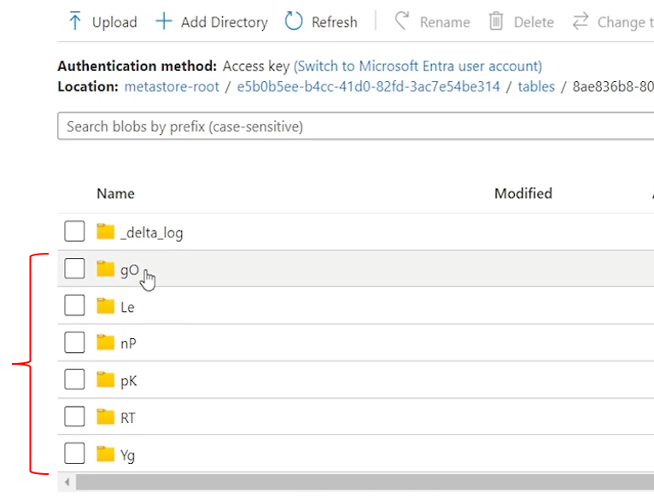

Let's go into one this. So I see one data file here which is like 35 MB. I don't know if it was the, there or it's a new one. here also I see a 39 MB data file. but. four of them were already there for the older version, reorganized data files and two are optimized data files. So let's do a vacuum on that so that we remove those four old files.

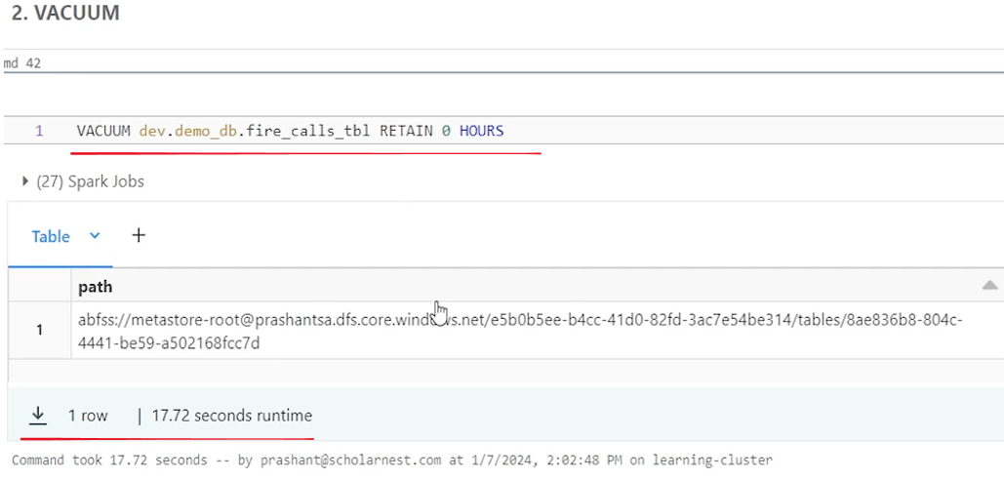

So let me do a vacuum once again. Usually after optimize you want to get rid of those small small files, older version of those small, small files at some point of time. So you will be anyway doing vacuum. So let me do the vacuum. Okay, so that's done. Vacuum is done. Now come back here at the directory. Try to validate what it has done. Refresh it. directories are still not gone. I still see six directories.

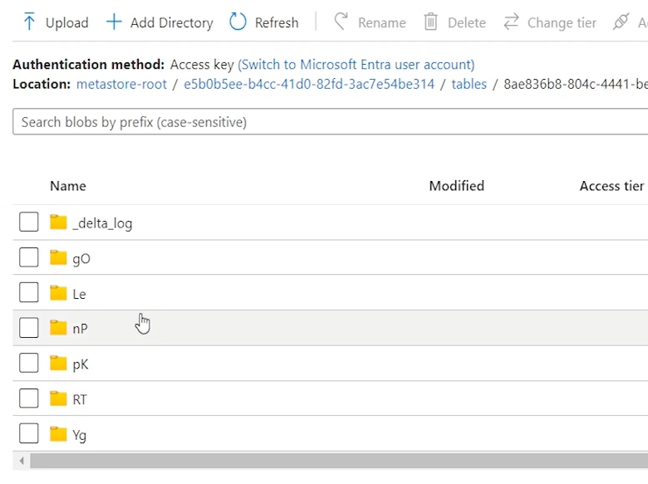

But let's go inside this directory. There is no data file. Right. So looks like files are vacuumed but directory is still there. This is also vacuumed. So four empty directories I am expecting.

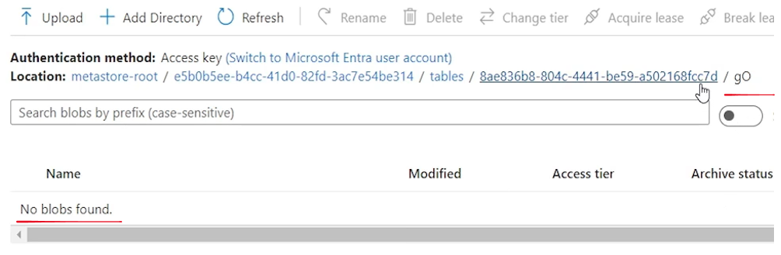

This is all this is there 76 MB. So maybe this is optimized file and p in the NP directory I found one file. Let's go to PQ directory here. Also I found maybe 90 MB which is an optimized file. So I already found two optimized files in NP and PQ.

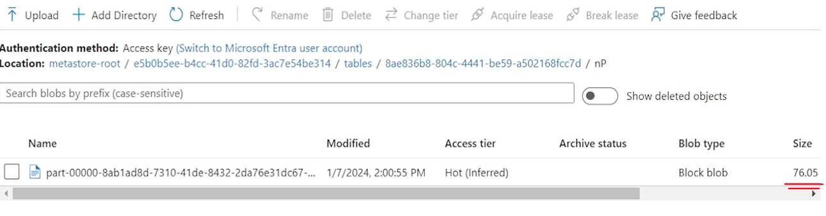

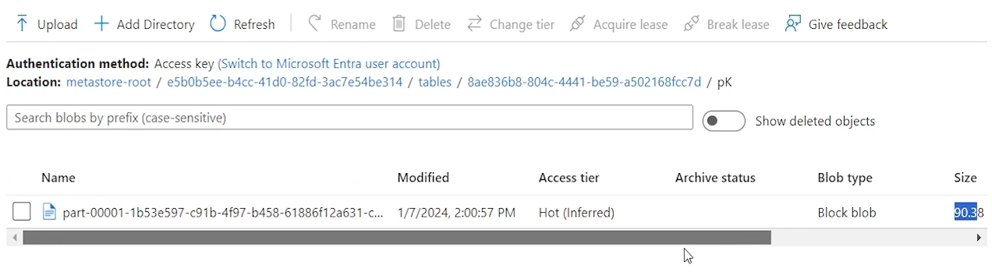

These two should be vacuumed already so no files there. And here also no files there. So that's how vacuumed worked. maybe it has done what we expected, vacuumed all the reordered files and kept only two optimized files in the data directory. We usually don't go into the data directory, do all that validations. But since we are learning and we want to make sure we are learning correct, we are validating everything that we are learning.

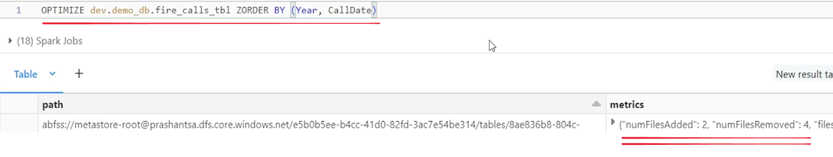

So that's all about the utilities and optimizations on delta tables. We will learn two three tools. vacuum reorg and optimize and also z-order.

## Incremental Data Ingestion

### Architecture and the Need for Incremental Ingestion



|  |  |
| --- | --- |
|  | we will learn about the incremental data ingestion in your lakehouse. So I'll start with explaining you the Lakehouse architecture and use case and scenario for incremental data ingestion. We will try to understand why do we need incremental data ingestion and how to do incremental data ingestion in your lakehouse. And once we understand the idea of incremental data ingestion, I'll go through three tools that Databricks offers for incremental data ingestion copy command, spark streaming, and auto loader. We will learn how to use these tools for incremental data ingestion while ingesting your data incrementally in your lakehouse. It is also essential to manage your schema. So with all three tools, we will learn how to manage your schema using manual schema evolution approach and then how to manage your schema using automatic schema evolution approach. |

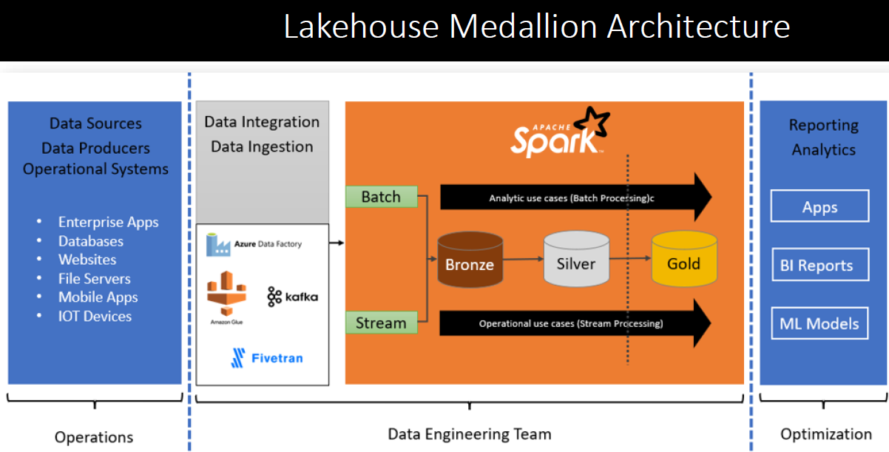

Lets quickly revise the Lake House Medallion architecture and how we implement Lake House Medallion architecture using Databricks platform. And then we will try to understand the approach for data ingestion into our lake house platform. So let's start. So our goal as a data engineering team or data engineering project is to solve our data problem. And we solve it more efficiently, more effectively applying some good architecture pattern for building our solution. And in modern days, Lakehouse medallion architecture is the most suitable and most widely adopted architecture pattern. So I hope you already understand this architecture pattern.

In this architecture pattern, we ingest data using the most suitable data ingestion tool from sources, and the goal is to bring our data into our bronze layer. And then we start building the rest of the data engineering project from bronze layer onwards. And how do we implement it or how do we build this kind of architecture using Databricks? We have already discussed that in the earlier lecture. So you build it using Databricks. But the point is that we need to bring data into our bronze layer for being able to process that data, prepare that data for our consumers, and solve our data problem. So bringing data into your bronze layer, which is your raw data layer, requires ingesting data from the source systems. The recommendation is to use the most suitable and most effective tool. For data ingestion based on your source system and the type of source system that you are going to collect data from. So we choose the most suitable tool, for data ingestion. But the end goal of all this data ingestion is to bring data into the bronze layer, ingest your raw data, bring it to bronze layer. So how do we bring it to our bronze layer?

We have one approach that these ingestion tools can directly write your data to your bronze layer database or your bronze layer tables. And they can ingest directly data into the bronze layer.

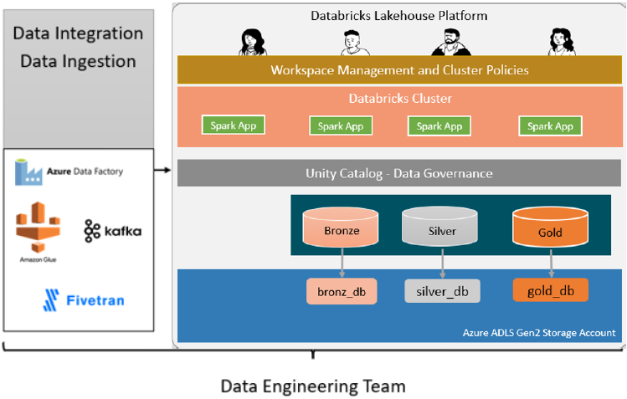

Another approach is to create a staging layer. Maybe use your cloud storage directory or some cloud storage location, and let your data ingestion tools ingest data and land it into the cloud storage directory, or at a staging place or a staging location. And this approach is most widely used. A lot of people use this approach for ingesting data. The reason is they want to decouple this data ingestion part from the lakehouse. The data ingestion, pipeline, or data ingestion project can keep on ingesting data and, staging it into a cloud location or in a cloud directory. And our Lakehouse solution is starting from building your bronze layer and then going forward, remains independent and it directly interacts only from the staging location. So from one side, data ingestion tool is bringing data and landing it into a staging location. And on the other side, within your Lakehouse platform, we write one job or one application or a small piece of pipeline here, which keeps on consuming data from the staging layer or a staging directory.

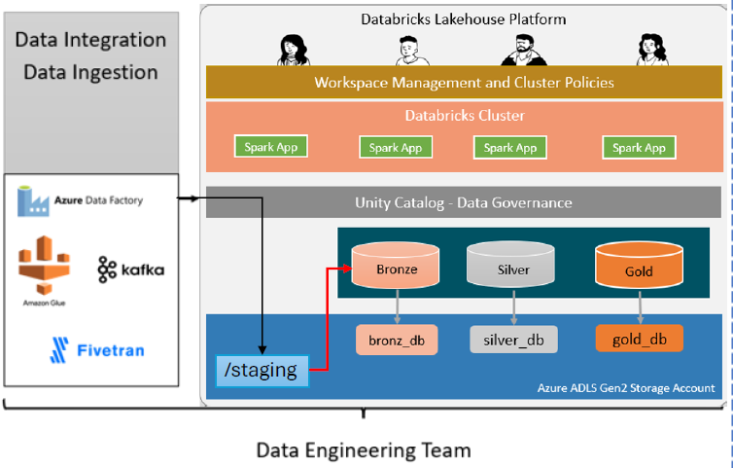

As data arrives and start building your bronze layer using delta tables. So that's the approach. For this approach to work, we need a good tool or technique for ingesting data from the cloud directories or from the cloud staging location, and bring it to our bronze layered delta tables. That's the idea. Databricks offers three approaches or three tools for building this. This small piece of pipeline where your source is staging area, and you can ingest data from the staging area and bring it to your bronze layer and build your delta tables.

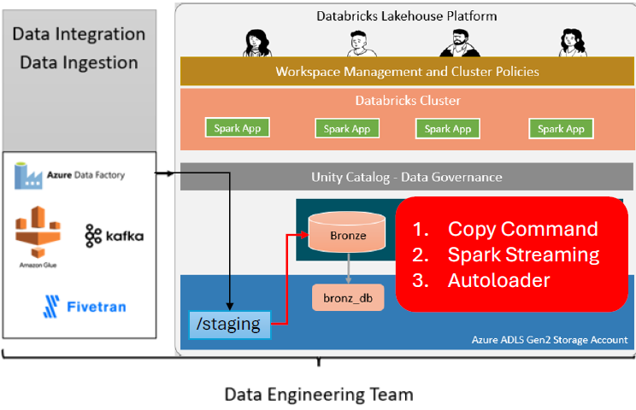

So we have three approaches or three tools available in Databricks. The first one is copy command. The second one is to use Spark Structured streaming APIs and build your logic. And third one is built on top of the spark structured streaming. It is known as Databricks Auto Loader. It's a specialized tool or a set of APIs built for, specifically designed and developed for reading data from the staging areas or cloud directories specifically. So we will also learn about the auto loader, what it is, and how it works. So that's all for this lecture. The idea was to help you understand the need for this type of requirement. So in many of the architectures, many of the solutions we ingest data into the staging layer, which is a cloud directory. And then rest of the solution is starts taking data from these staging builds the bronze layer and then take it forward. So that's we are going to learn three approaches for ingesting data from a staging layer.

### Using Copy into Manual Schema Evolution

We want to learn to use copy tool or copy command for ingesting data from a landing zone. So let's start. As usual, I'll go to my workspace and open. notebook that I have set up for your demo, and we'll run the cleanup. And then when we'll do the setup, basically, I'm setting up a data base in a dev catalog. Simple things. What do we want to do or what do we want to learn? In this lecture, we want to learn how to use copy tool to ingest data from a landing zone directory to our. Bronze layer table. That's simple requirement.

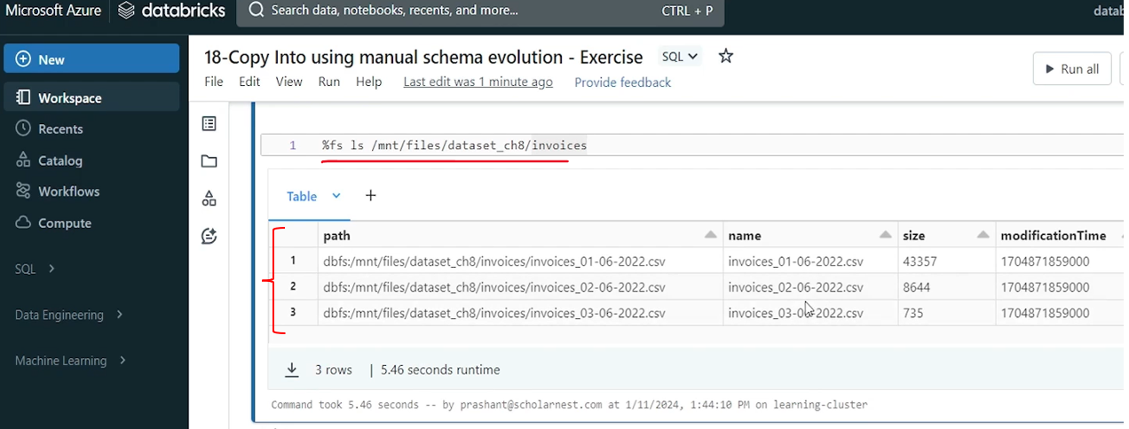

We want to learn how to do it using copy tool. So to simulate that scenario I have created this directory in my mount directory. I have created this invoices directory and we are making an assumption. This is my landing zone directory. So my ingestion tool will keep on ingesting data files into this directory. I already have three files here for starting my test. So we assume that some files are already ingested there. Now we also need to create our bronze layer table. We want to implement this requirement using manual schema evolution. So we want to fix our bronze layer table schema. So let's create a bronze layer table for invoices I will simply paste the create table DDL statement here and run it. so we are creating invoices_raw. That's my bronze layer table a very simple table.

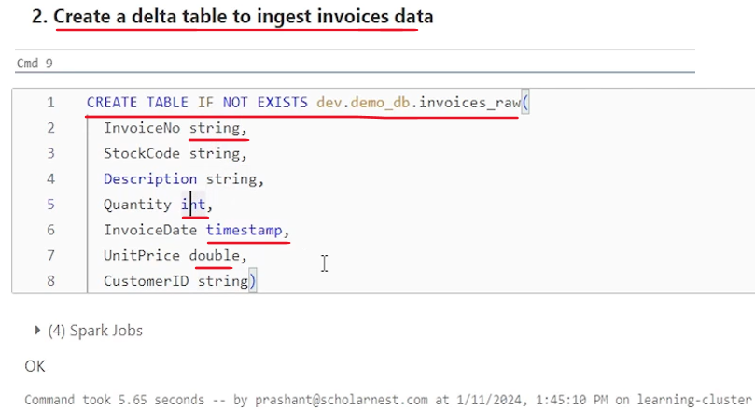

We have few fields. Some are string some int timestamp double. That's the schema for my, uh, table. Now we want to ingest data from, landing zone using the copy tool command with the fixed schema. So how to do it? Simple. we can use copy command or copy. It's a simple SQL like command, so copy into and give the table name. In which table do you want to ingest data, so copy into this table and then we have to specify in just from where. And in a pair of parentheses we can write our SQL like statement. That's my source right. So let's say select star from from where we want to ingest from a landing zone directory. So that's my landing zone directory. Right. So we ingest from the landing zone directory. But I will also have to configure the copy command to tell that this directory will contain CSV files. So whatever files we have in this directory what is the file format. So I have to specify file. Format here. File format equal to CSV. That's all. So. Once you tell the file format CSV, you also have an option to use. CSV file format options like header, info schema and other kind of things. Right. So we already, learned reading data from CSV file and CSV file options. So I can use some of the options. Let me use header option because my file comes with a header row. And I want to skip that. So how to give format options. Format underscore options, and in a pair of parentheses you can specify the options. So. Let's say header equal to true. That's the only option I want to give. And maybe if I want some more options I can put a comma here. And I start typing rest of the options. So that is kind of all copy into this table from. Select star from this directory. What is the file format? CSV. What are the format options you want to tell? I just want to tell header equal to true. that's kind of enough, but I. Have a requirement to ingest data from this CSV files in this directory with a fixed schema.

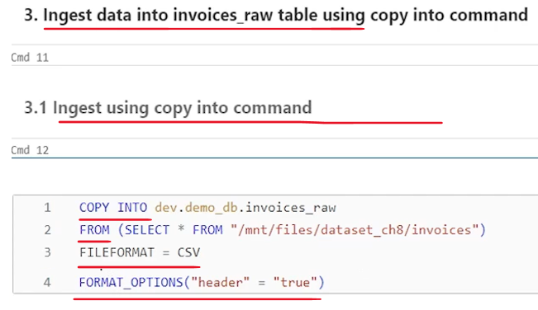

I don't want to implement automatic schema evolution and all that. We want to fix the schema because I have already created the table and it has a fixed schema. So we want to make sure that whatever data we are ingesting is coming with this fixed schema. So how to do that? let's define the proper detailed select expression like select invoice number and then stock code. We don't use select star and all that. Right. So that's how we can specify all the list. But I also want to make sure that these fields are of the desired data types. For example invoice number should be string. Quantity should be int invoice date should be timestamp and all that.

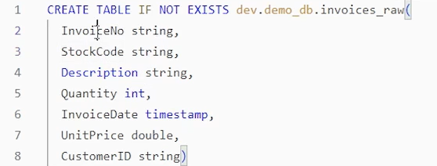

How to make sure that in the select statement I can cast the invoice number to a string. Similarly, I can cast all the fields to a desired data type. So I hope you learned that in Spark Programming, we in Databricks we have this double colon, which is a shortcut for cast in this SQL expression. So invoice number colon colon string will cast the invoice number. Make sure it is an string. And similarly colon colon string will cast the stock code and make sure it is an string. We have few more fields. And let me paste it here. So. We are done. With the one, 234 fields. What is next? Up to quantity. We are done. Next is invoice date. I want to make sure that invoice date is interpreted as a timestamp, but I know it's a CSV file. So in CSV file things are like a string. So let me convert this invoice date into a timestamp. How can you do that? Simple you can use to. Time stamp and tell the invoice column and then tell the format right. And once you have the format, maybe you can, give an alias back to invoice date. So what is the format? I should be knowing my, data file. I should have an agreement from the source system that. What is the date, or timestamp format they are going to send. So I know my data files. I know my data format. So my data is coming with this d m y format, and then H and then only minute I don't have seconds coming in my data. So this is my, format. So I made sure that invoice date is also sticking to the fixed schema that I have. I have two more fields left, as per my table design. So let me paste that unit price is double, customer ID is a string. That's all. My copy command is done. And let me run this.

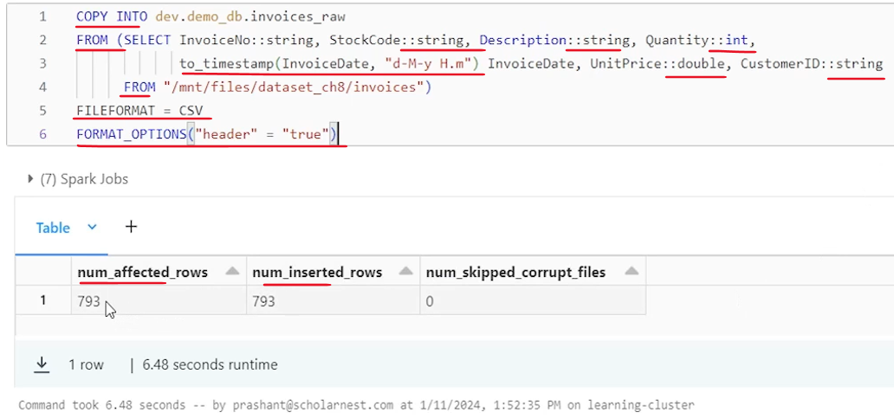

So I executed it and it ingested 793 records. And I know in these files I have these many 793 records. So I ingested data from these files. what if I run it again? Right. Or maybe before, running it again. let's try, checking the table. Select a star from the table. Let's quickly check 793 records should be there, so I've got 793 records there.

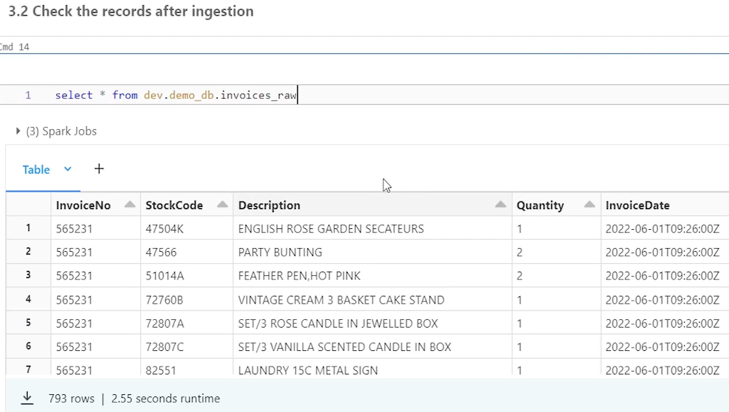

But what if I run this copy command once again? Let me copy it and put it here. it already ingested 793 records from these three files. Will it ingest them again? Will it create duplicate records? The answer is no because copy into is idempotent. It will not ingest the same file again even if you run it two times, three times, four times. And that's how copy tool allows us to do incremental data ingestion. So first time we ingest whatever data is already available in the cloud directory. Next time we run the copy into command, it will ingest only new files if they have arrived into the directory. And that's what you can do. You can write copy into command and schedule it to run again and again, every five minutes, ten minutes or whatever the requirement is. So if I run it again, the number of records impacted are zero. Run it again.

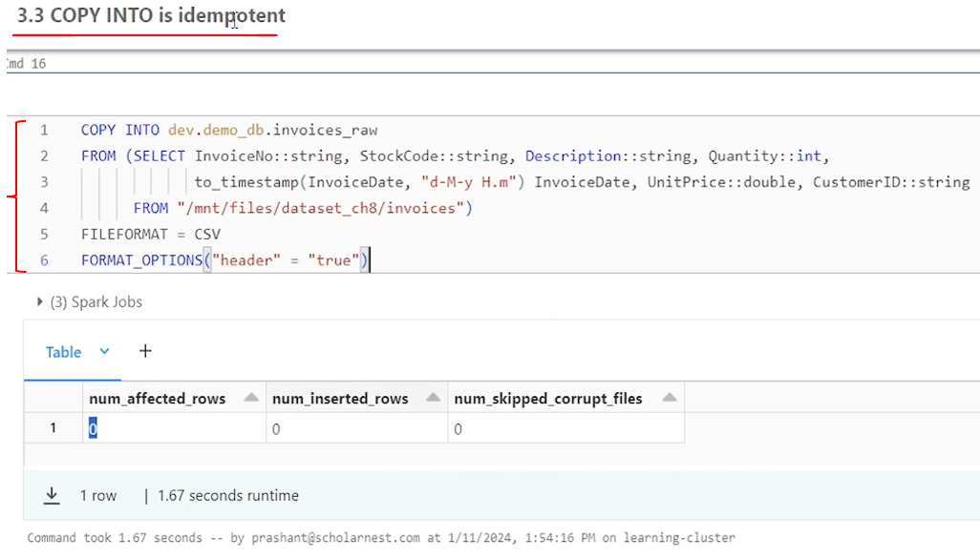

And no matter how many times you run, those files are not going to be ingested again. if new file arrives into that directory copy command. If you run it again, it will ingest the new file. So let's, check the data once again. make sure I ran it two, three times. Copy command again and again on this same. So let's see. do we have some duplicates? No. Same 793 records. Nothing is inserted.

Looks like customer ID is null. Is it? Okay, so maybe in the data file some customer IDs are not there but some are there. So we are ingesting it. Now let's simulate the next step. Let's assume that we ingested some new files again into the same landing zone directory. My ingestion tool has ingested some new data and saved it as the, file in my directory. And for to simulate that scenario, I am copying this new file from this directory to my landing zone directory. just to simulate that some new file is ingested. True. So file is copied there. Now we should have four files there. This file is also copied into the landing zone.

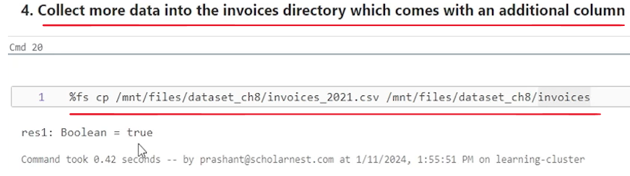

What if I run the copy command again, it should ingest data from this file also. Right. So you can run that. You can try that. I know it will work, but we have a scenario here in this data file. We have one additional column. I have specifically created that scenario. This data file comes with one new column. So we are simulating a scenario. What happens if, you ingest a new data. And that data comes with the additional field. What do you want to do. Do you want to evolve your schema and accept that additional field.



Or you want to ignore that, additional field. You don't want to ingest that. Let it come, but we just want to ignore that and ingest only those fields that we designed initially, in the table, this is the table structure. We want to ingest only these fields. It depends upon your requirement. So if your requirement is to ingest, only these fields ignore any new fields. If they are coming, you don't have to make any changes. Your copy command copy into command, as we have written here, will work smoothly. You can run it. The idea is that your ingestion code will not break, but silently ignore the additional columns. Right. If you have received any new column in your data file. But let's say I have a requirement to accept it. I want to take that new column also. whatever is coming in these files or the new files, how to do that? We want to implement a manual schema evolution approach. So manual schema evolution approach is to make code changes manually.

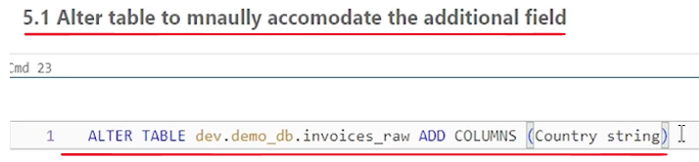

Once you know that you have some new fields coming in and you want to incorporate them also or ingest them also, you will go and make some adjustment. The adjustment is evolve your schema and tweak your data ingestion code to start accepting the new field. So how to evolve your schema? Use the alter table command. Right. So let me copy paste the alter table command here. So here is my alter table. this table add columns country, which is a string. So I'm adding one new column here. a string type. And then. My schema evolution is done. But. This code, which is my. Copy into command. It doesn't accept the additional column.

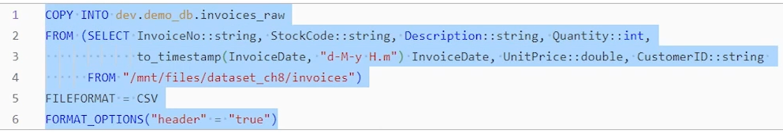

So as part of the change I'll have to implement the additional column also.

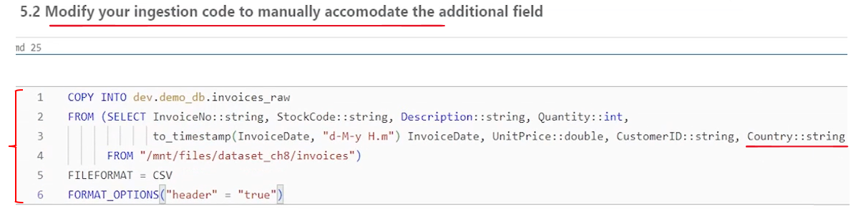

And what is the column name country. So I'll incorporate country and also make sure it is a string. So kind of done. I have incorporated my additional column, and I have also evolved my schema to add the additional column. But one more small thing is left here. the CSV format reader, the CSV reader will give us problem because there are three files which had some n number of columns, but we got fourth file, which has some extra columns. So CSV reader might not be able to, read that. So what we want to tell CSV reader in the format options that merge these schema, if there is a schema difference in, two files. So so let me set that option here merge schema equal to true which will allow CSV reader to read two data files are more files, even if there is an schema difference between these two files.

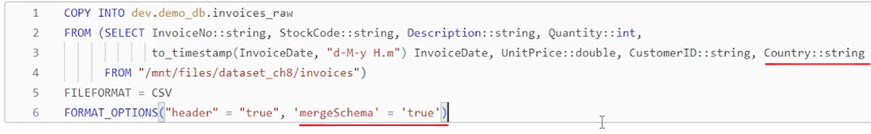

So let's try to run it now and it should work. So we ingested some 254 new records from that file. If you want. Earlier we had 793 records. Now, if you want to. Check your table once again.

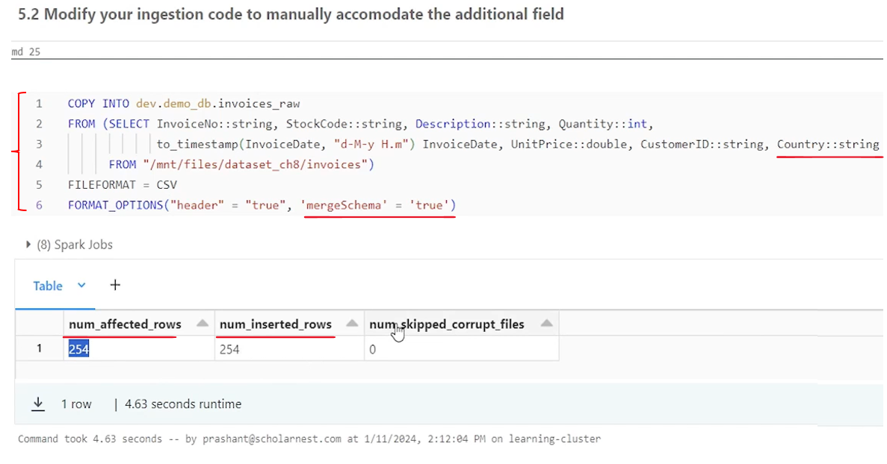

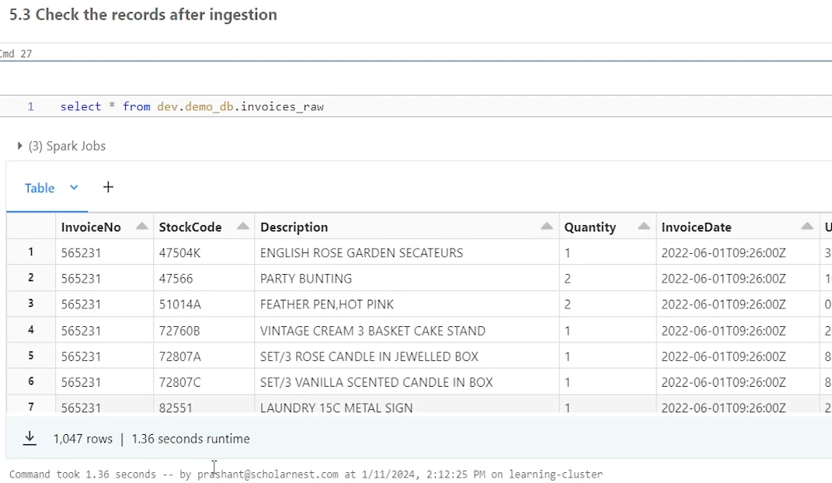

After ingestion you will see some additional records. So that's all about copy into using manual schema evolution approach. copy into is a very simple, straightforward command with very less options. You copy into the table in the From clause you can give a select expression. The select expression allows you to read from, directory location. This directory location could be a mounted directory location or it could be an external location.

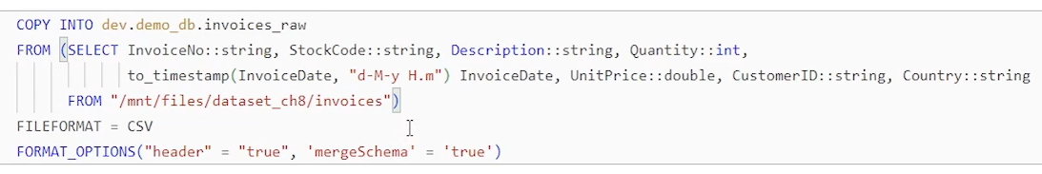

All you have to make sure that you have access permissions to read to from that directory. And then you can tell format. It supports various formats like Json, Avro, parquet and all usual formats. And you can also specify format options if you want.

### Using Copy Into with Automatic Schema Evolution

we will learn to work with the compute Tool or Copy command once again. But this time we will learn to implement automatic schema evolution. So let's start as usual I'll go to my workspace. And open a. New notebook for this demo. Connect with a cluster. Do a bit of cleanup. And then do a setup. So we are now ready to work on this scenario. Let's look at our landing zone directory. So. We have three files in our landing zone directory. Our ingestion tool is ingesting data into the landing zone directory and creating files. We want to use copy tool to ingest data from the landing zone.